**FROM THIS….**

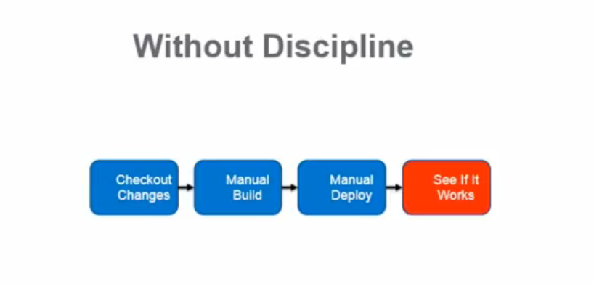

**TO THIS….**

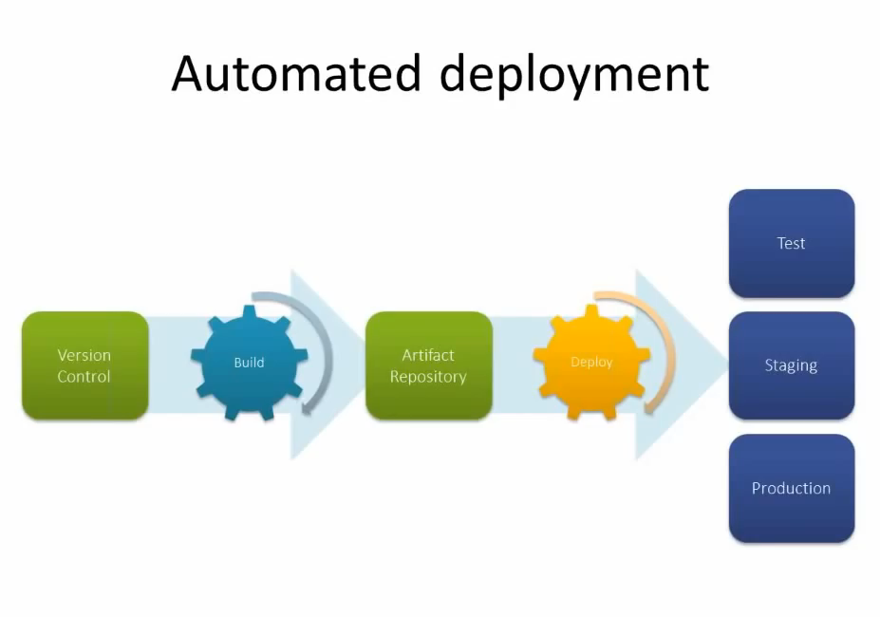

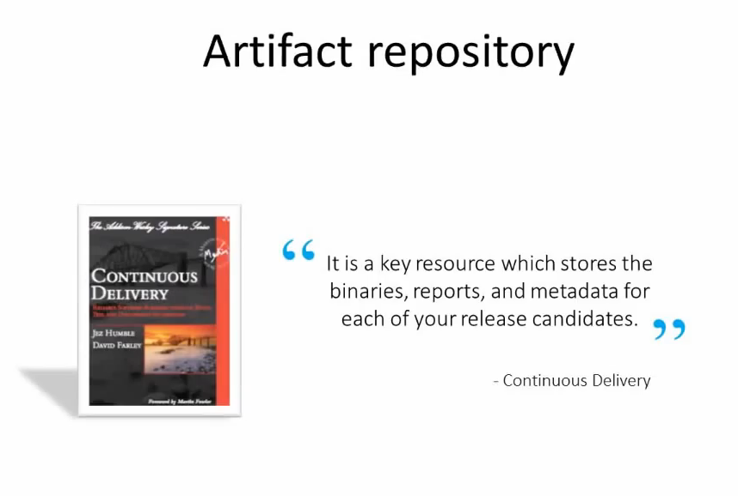

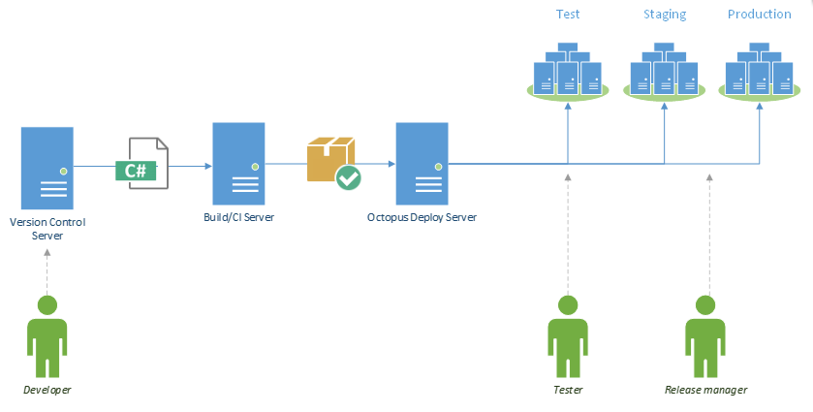

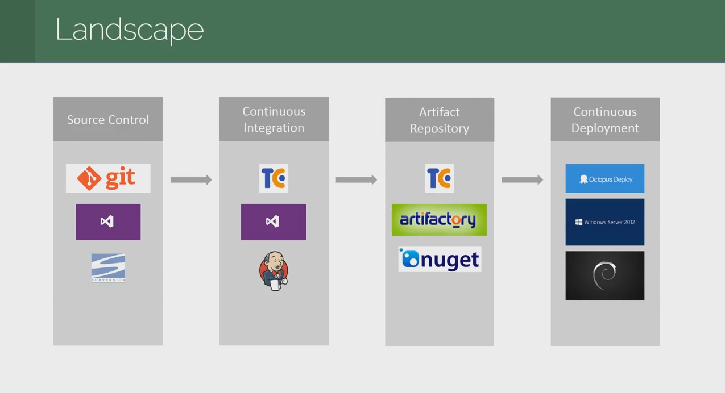

* **Continuous Integration (Team City)** – automatic build process, creates “Artifacts”
  + TC Supports hosting Nuget package feeds--great Artifact Repository
  + Checking for changes in source control
  + Compiling the code
  + Running unit tests
  + Creating NuGet packages for deployment
  + (optionally), having TeamCity trigger deployments in Octopus when a build completes

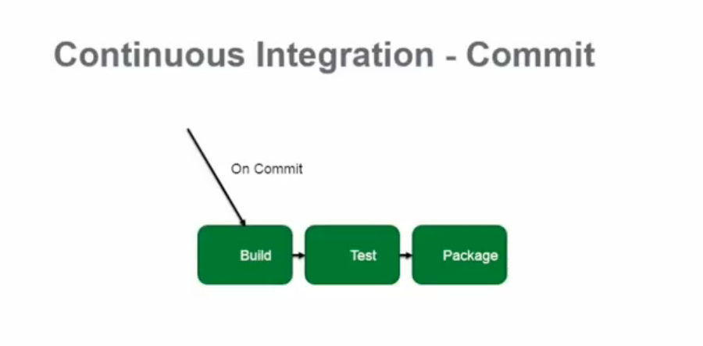

**Continuous deployment**

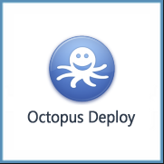

**Octopus Deploy** – automatic processes to pick up artifacts --those NuGet packages from TeamCity-- and to push them to development, test and production environments.

* + Pushes out to staging/UAT (user acceptance testing)/production servers
  + Octopus Deploy works well for this, supporting Nuget package deployments

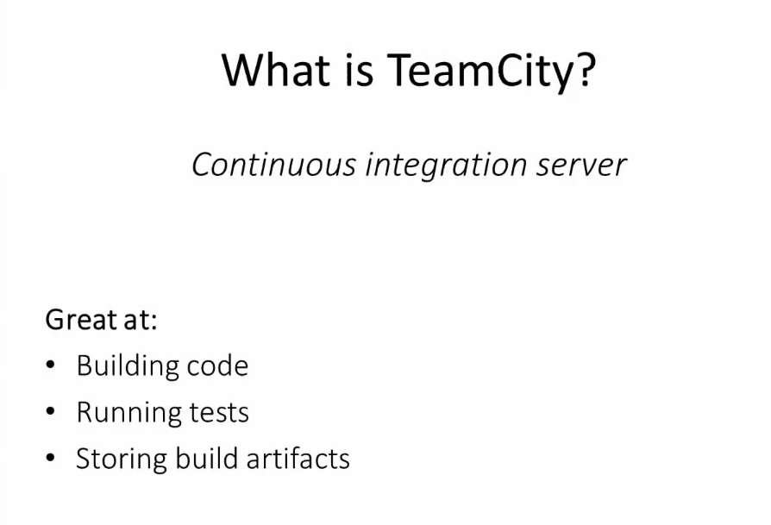

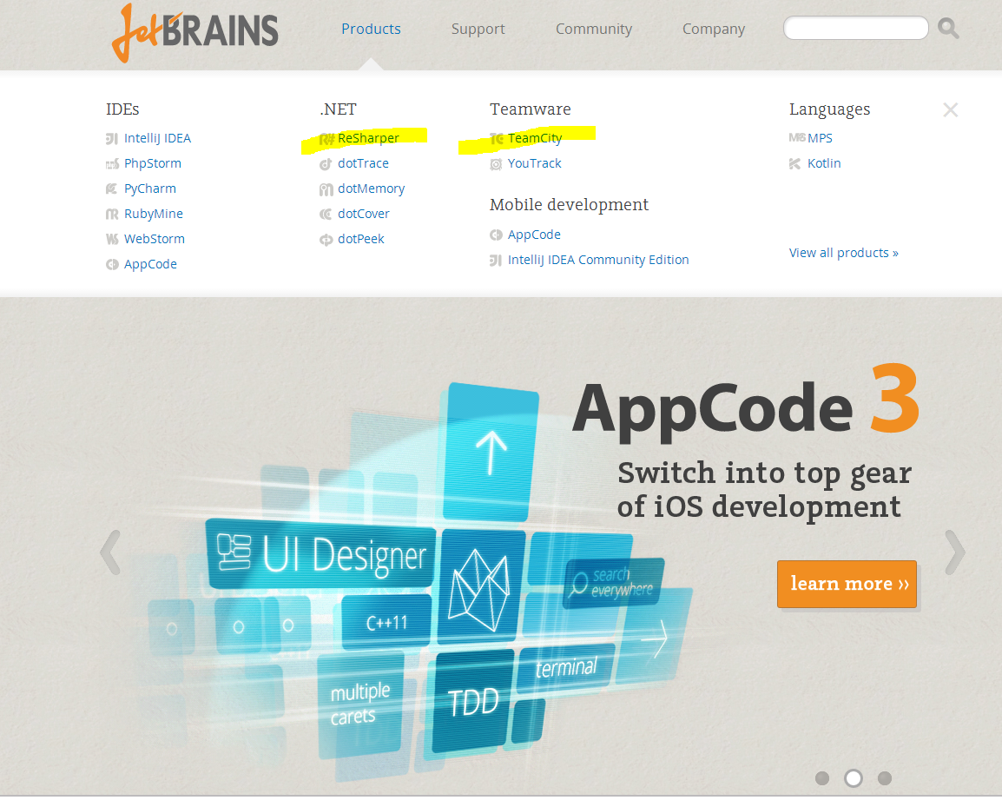

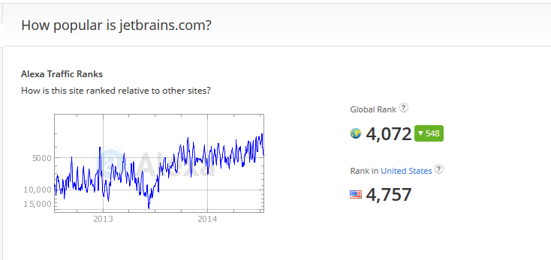

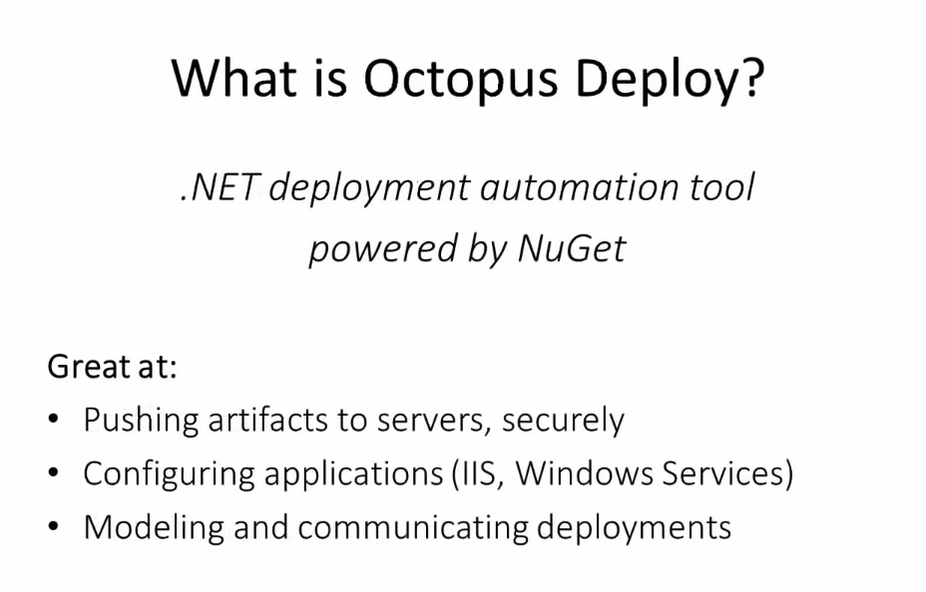

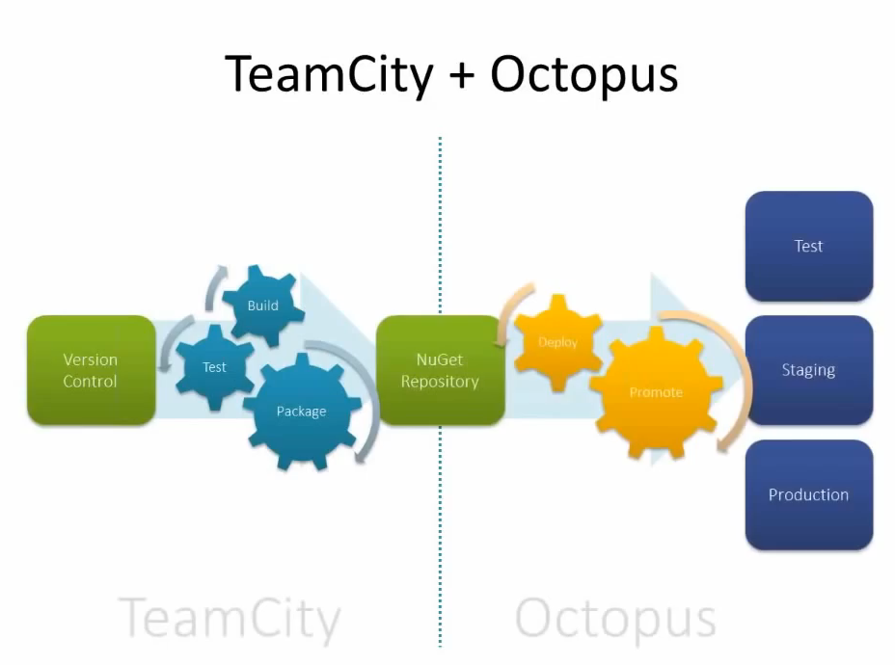

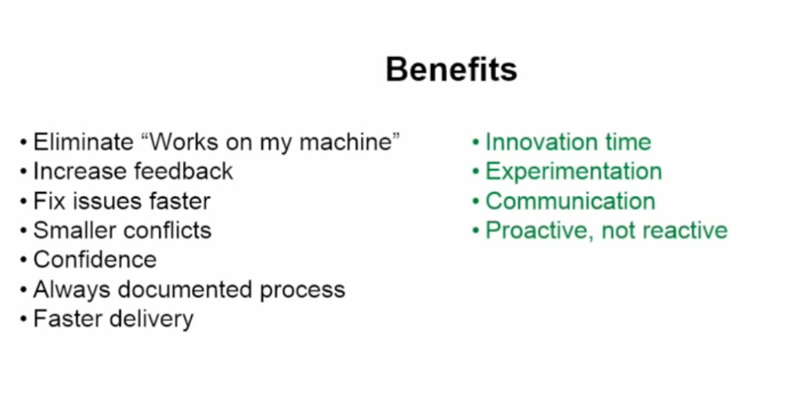



Watch 1st Intro video

<http://www.jetbrains.com/teamcity/documentation/userguide.jsp>

SETTING UP FOR ON EVERY “COMMIT” BUILD, TEST, AND PACKAGE…

*After setup and logging in, create a project, then click on create build configuration*

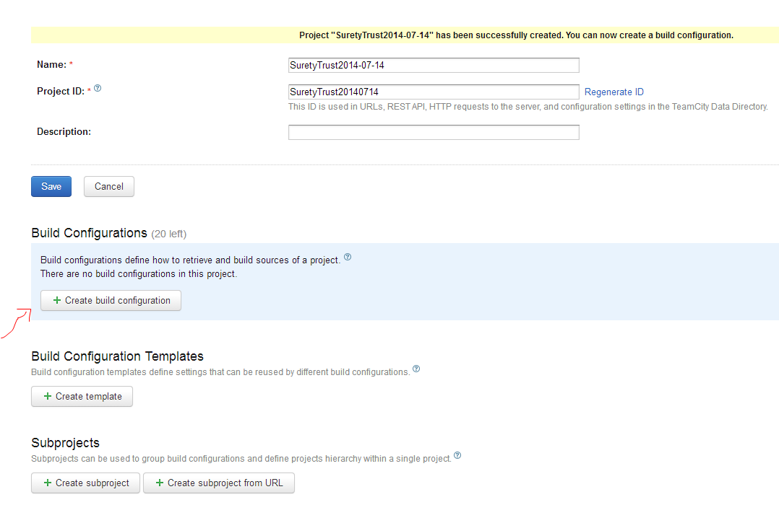

Creating a build called “Commit”

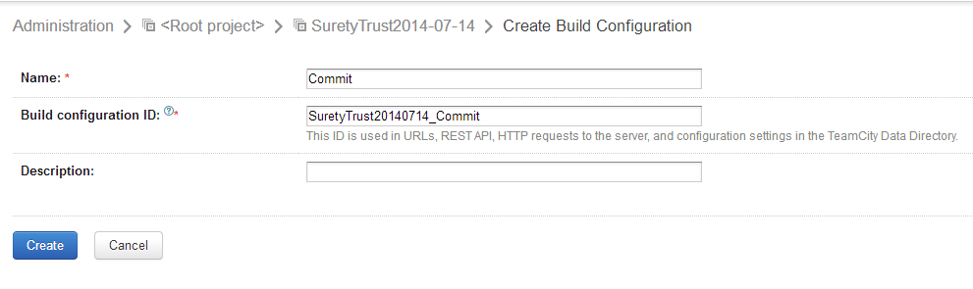

Configure VCS (version control settings) roots

Use following for root name and Fetch URL

ssh://git@sourcecontrol.amtrustservices.com/gitrepos/WebApps/SuretyTrust.git

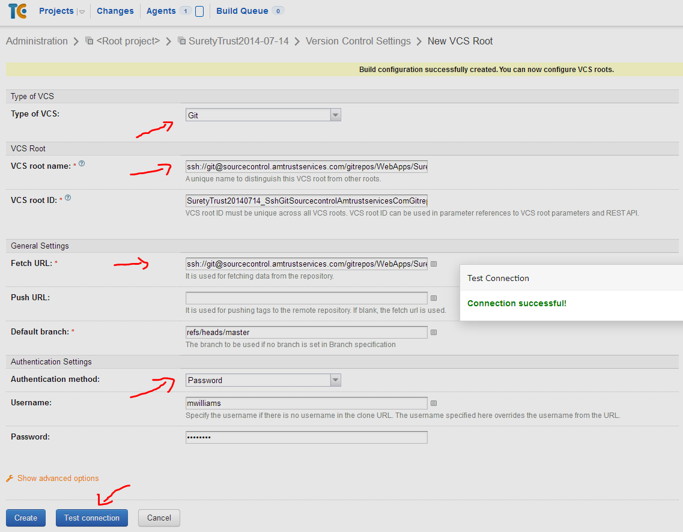

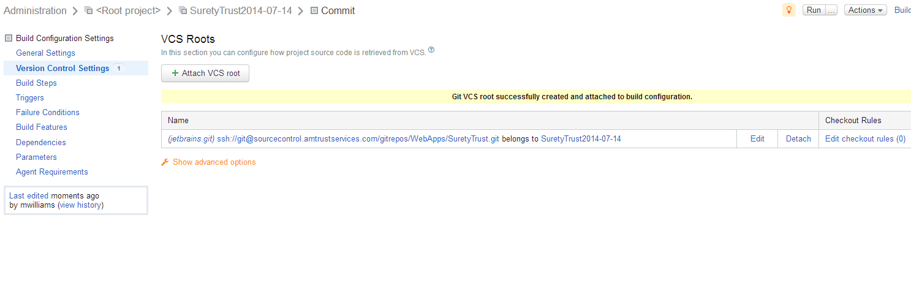

Select build steps and select “auto-detected”

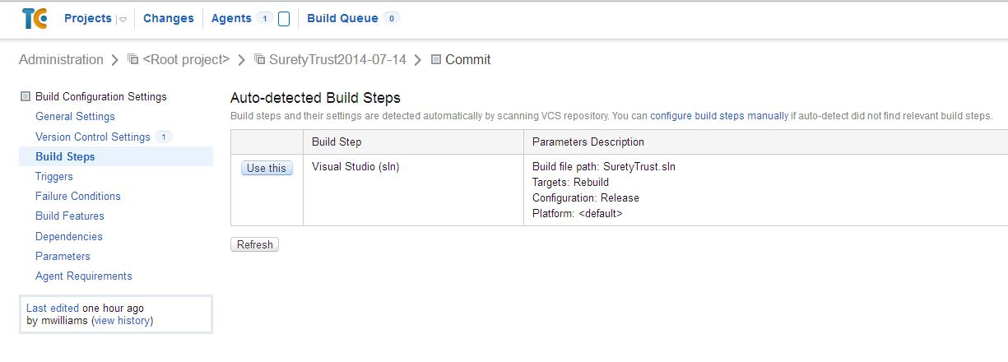

Run build

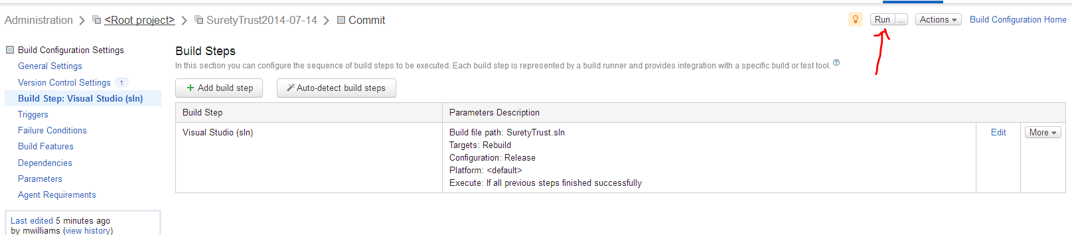

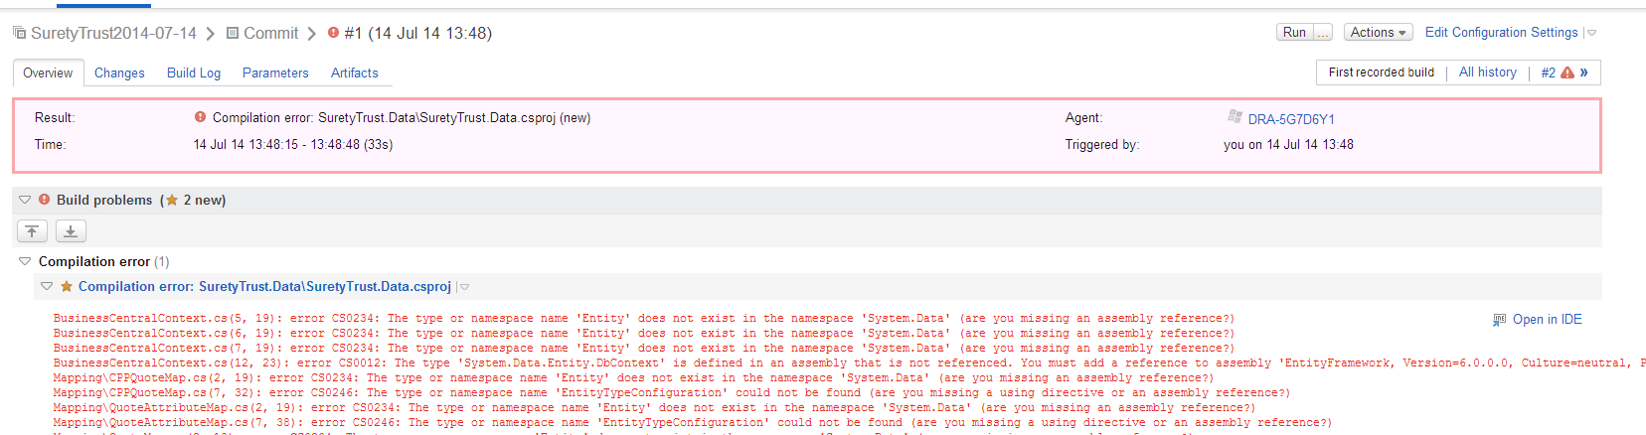

Add another build step for NuGet

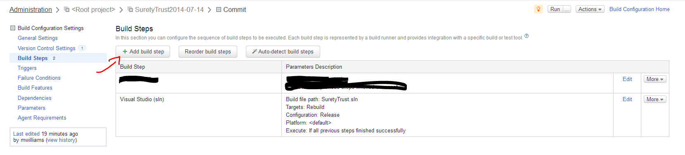

Select NuGet Installer

Set the path to the .sln file as just SuretyTrust.sln because the root is already at C:\<source control>\WebApps\SuretyTrust

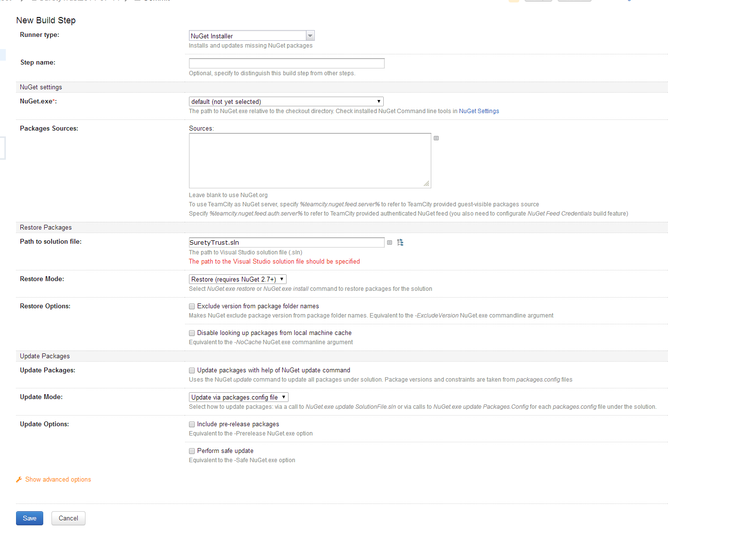

Go to NuGet Settings -> NuGet.exe tab -> Fetch NuGet

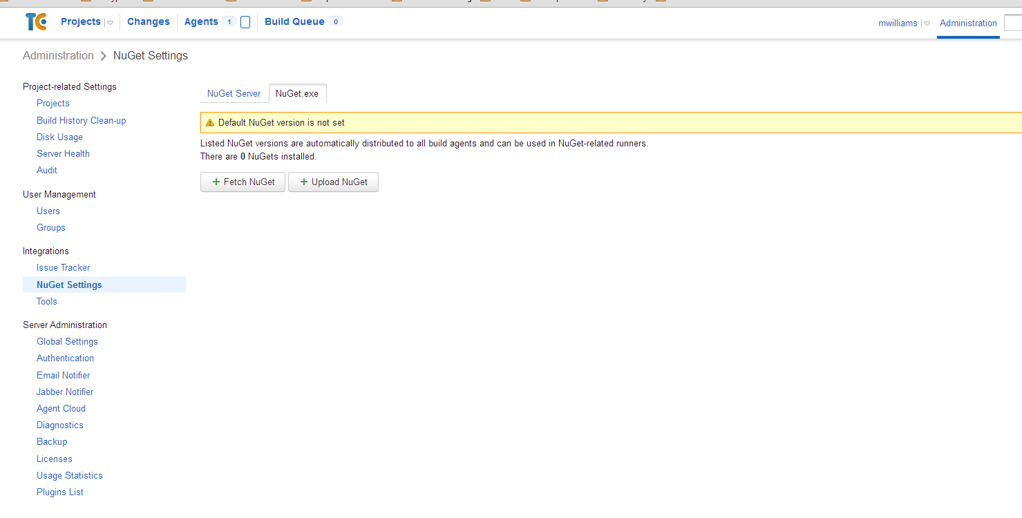

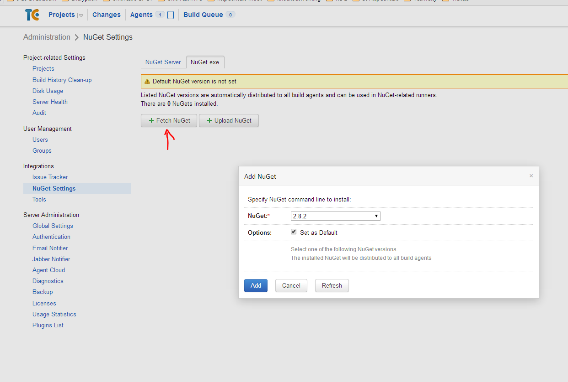

Identify Artifacts of the project

*Build artifacts are files produced by a build and stored on the TeamCity server*

Figure out what files are needed by publishing from VS to a local file directory

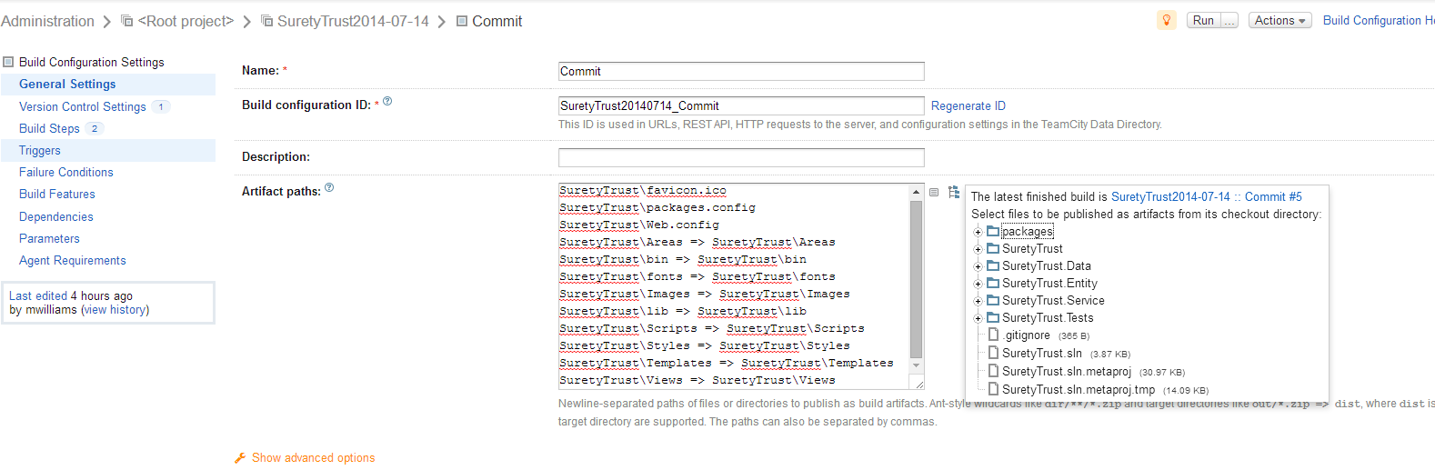

***Right now just grabbing everything***

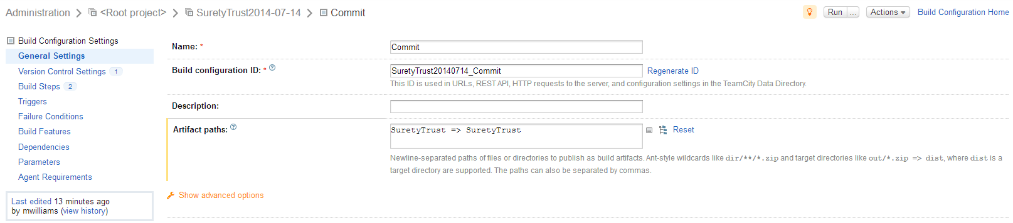

ADD BUILD STEP TO RUN UNITS TESTS -> <http://stackoverflow.com/questions/16408166/teamcity-setting-up-mstest-2012>

*\bin**.Tests.dll

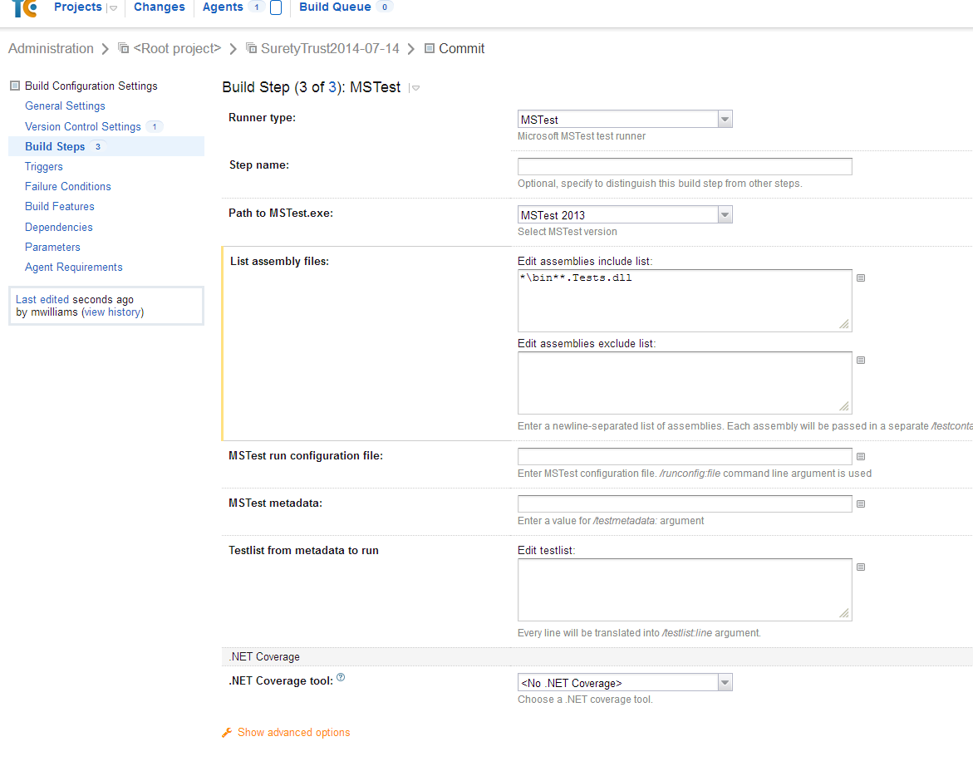

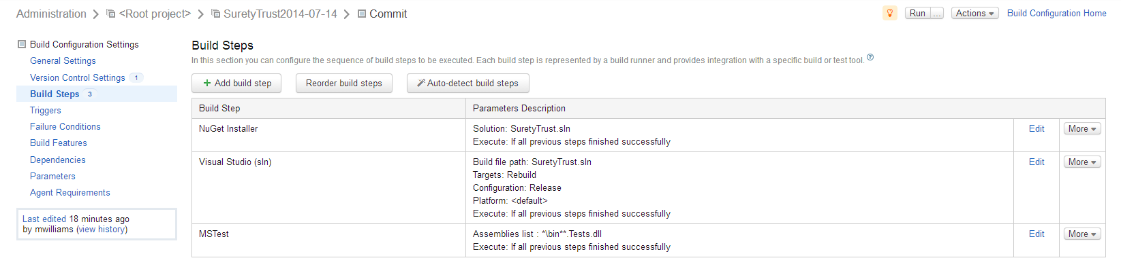

*3 new Unit Tests Failed (previously there was only 1 that I knew of that was failing)*

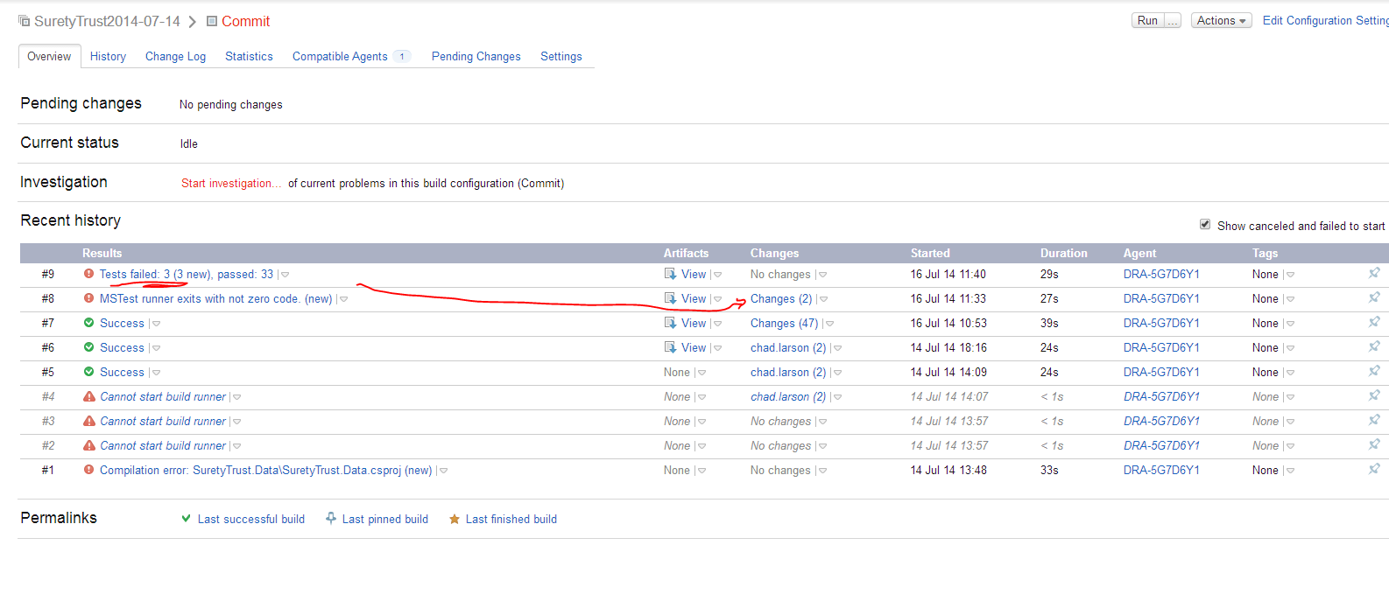

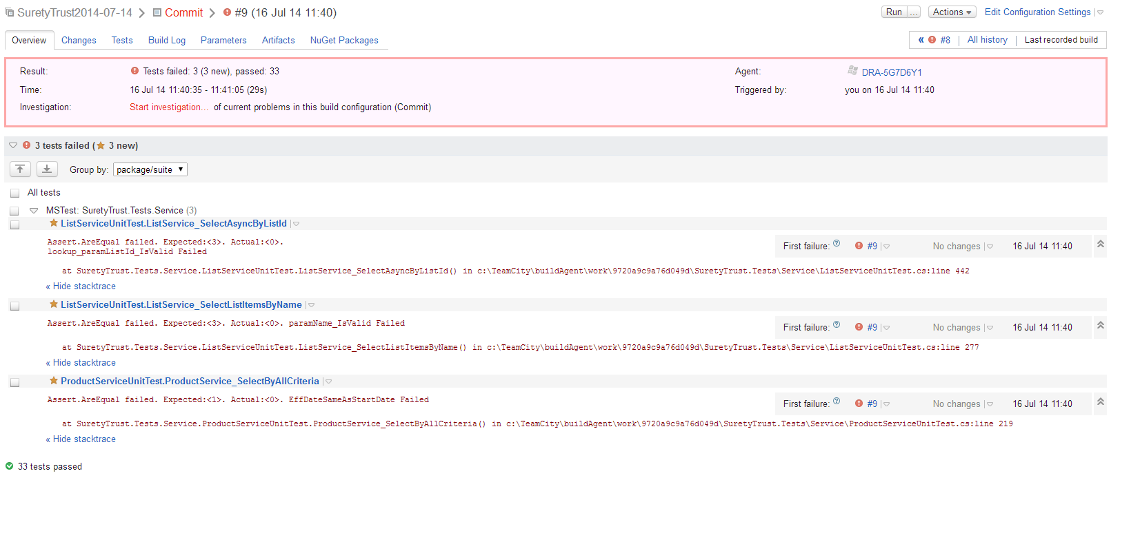

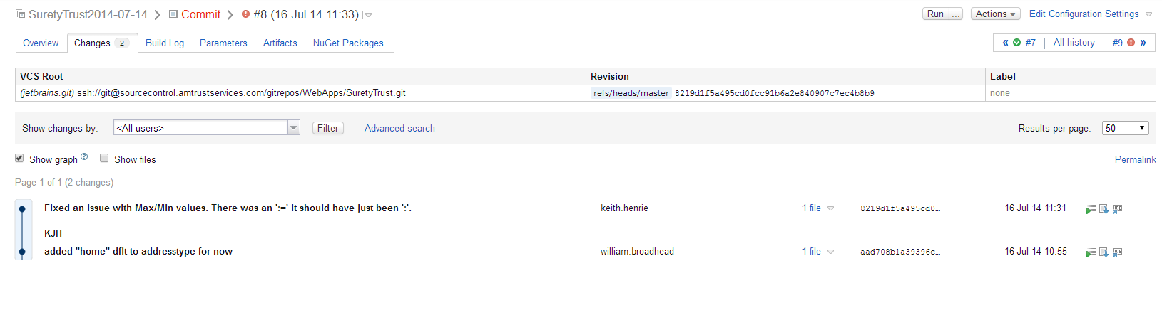

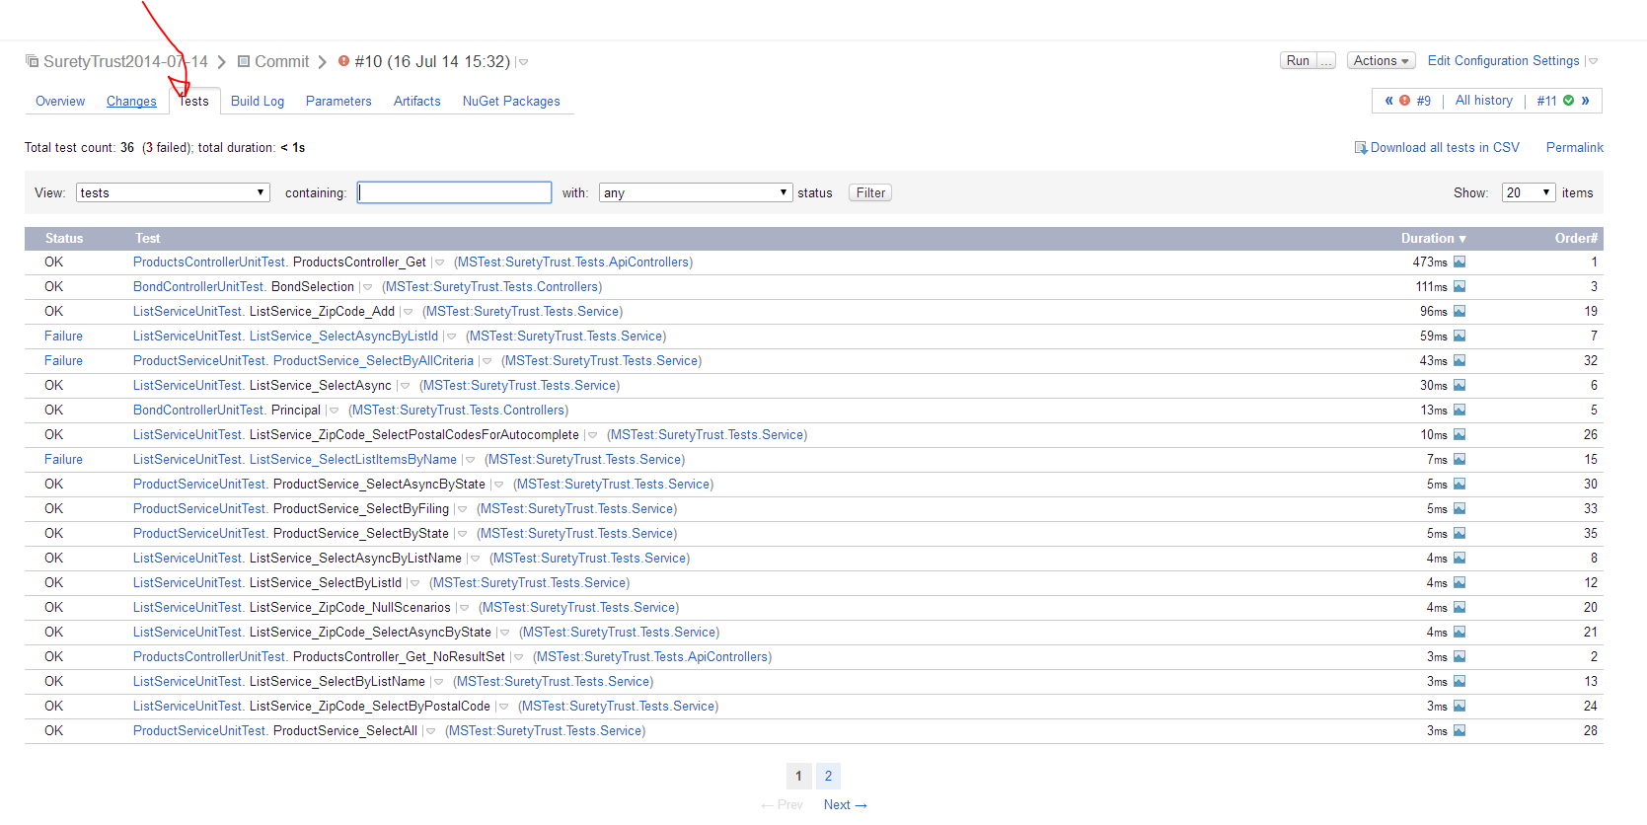

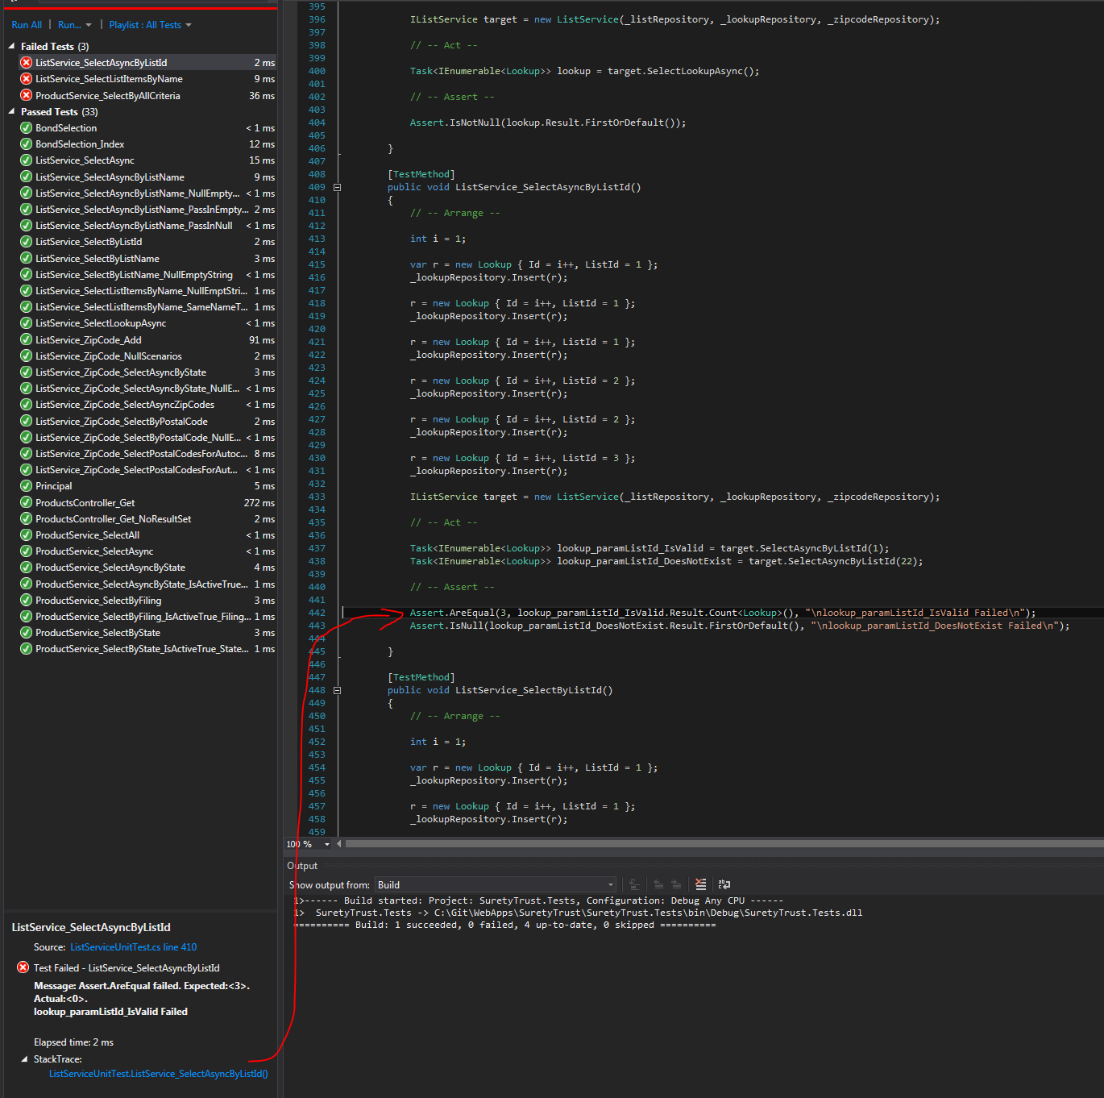

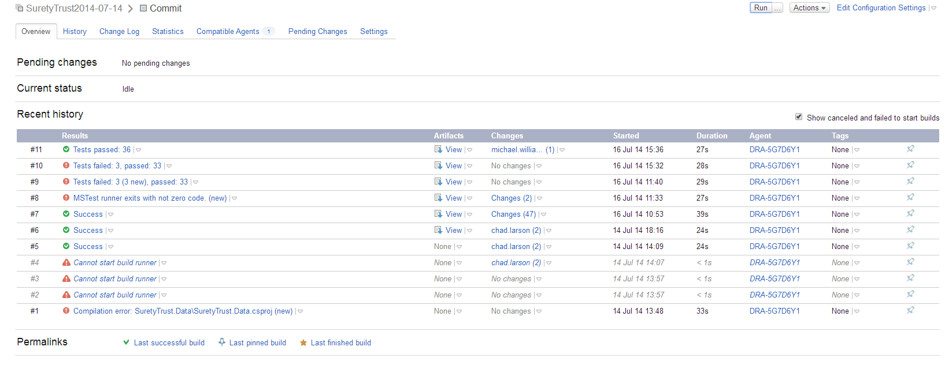

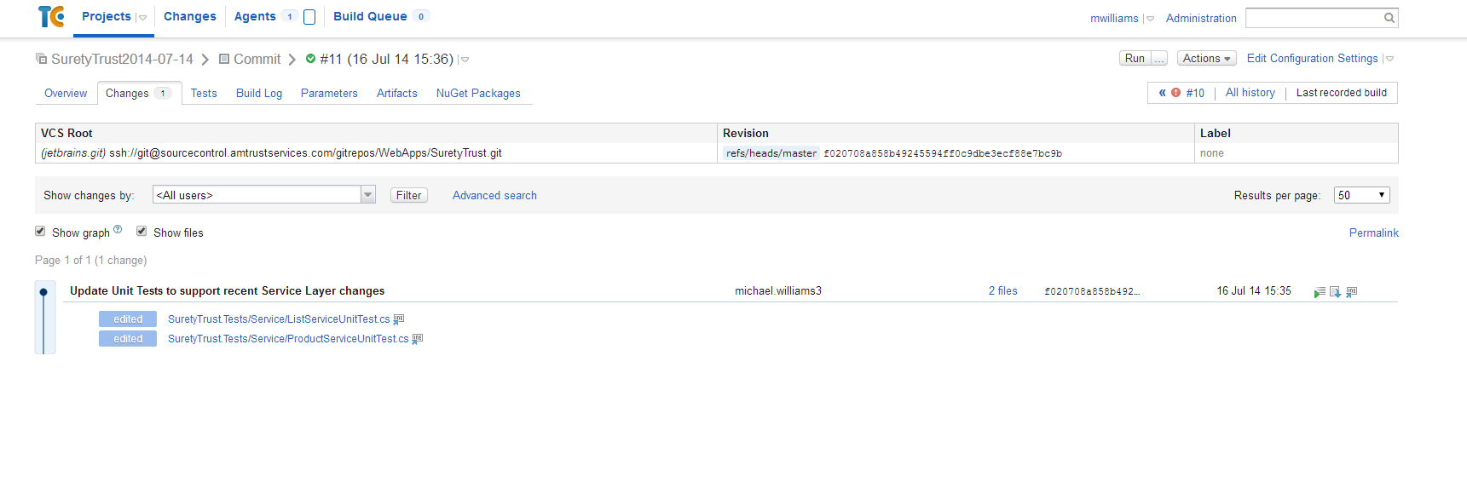*\*

***Going back and looking at older test results….***

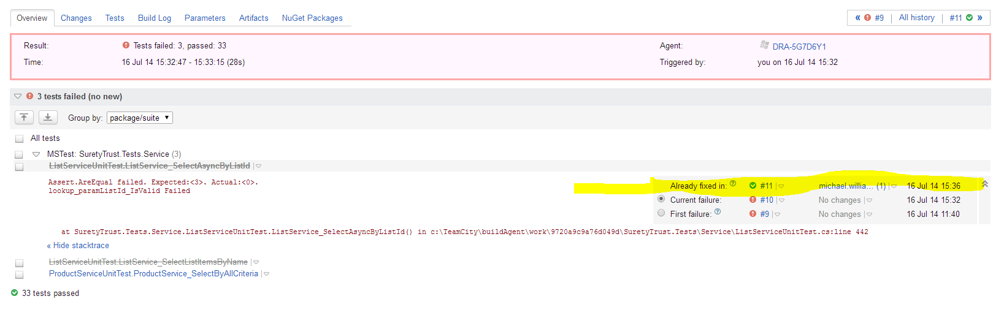

**ADDING TRIGGER TO RUN BUILD ON EVERY COMMIT 🡪 “COMMIT BUILD”**

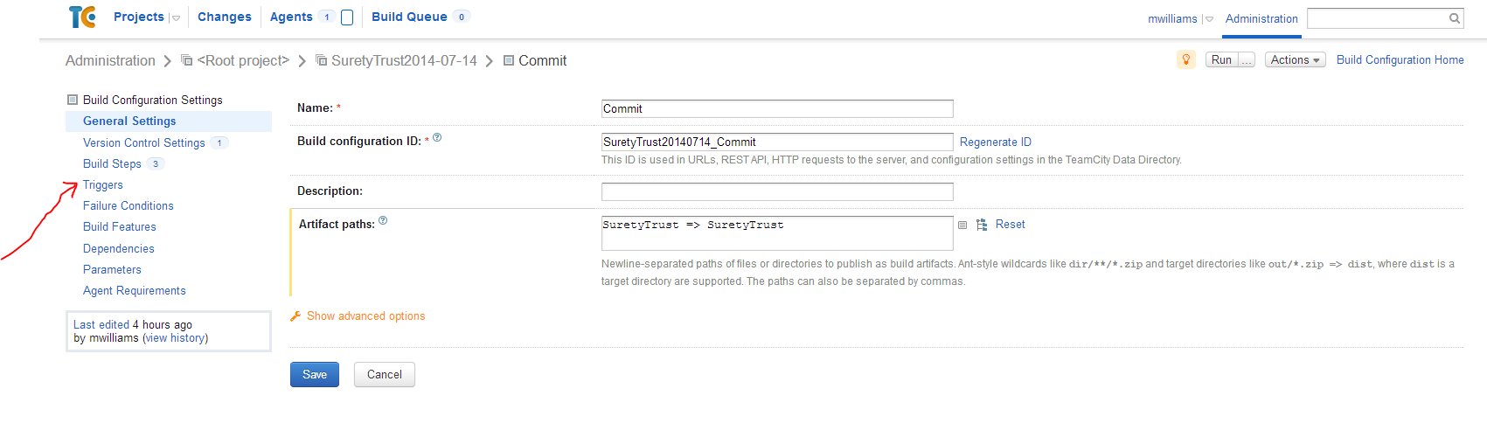

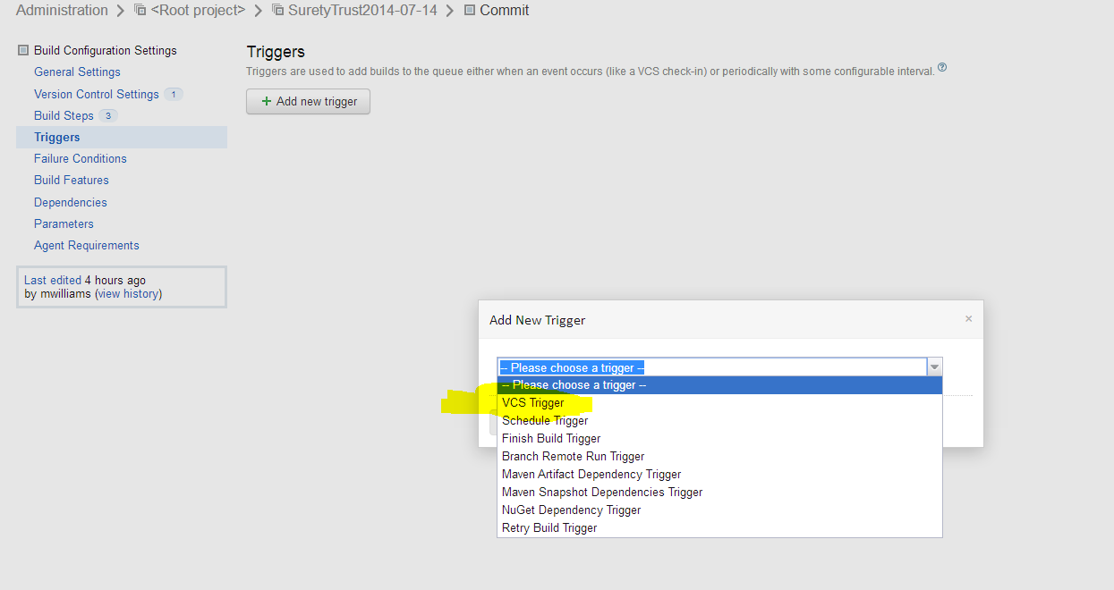

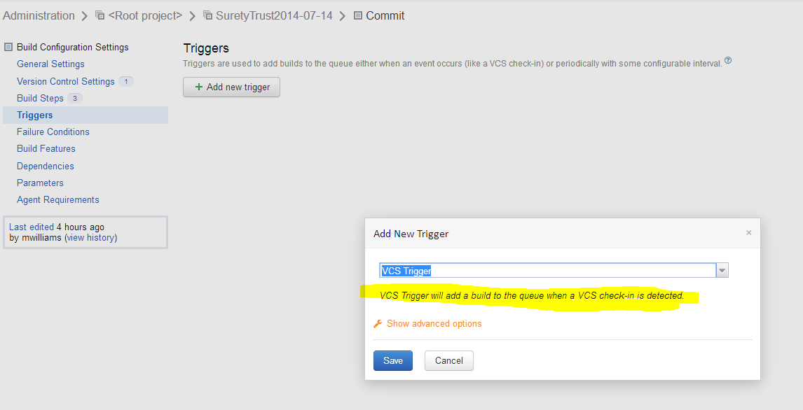

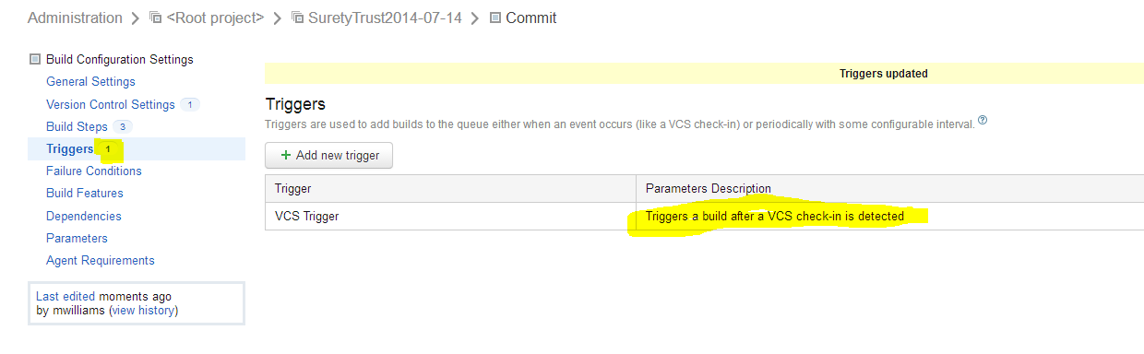

**<check in a change and show in following view Team City pick it up>**

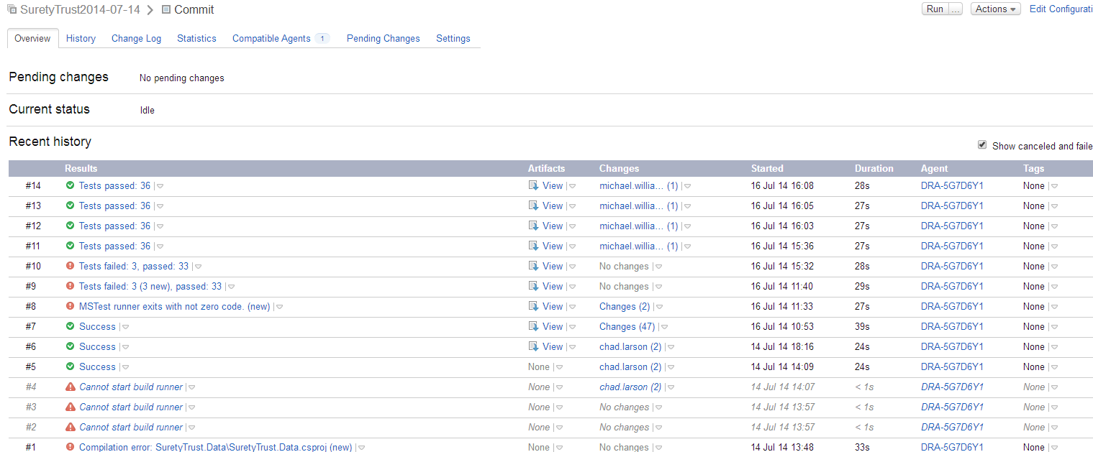

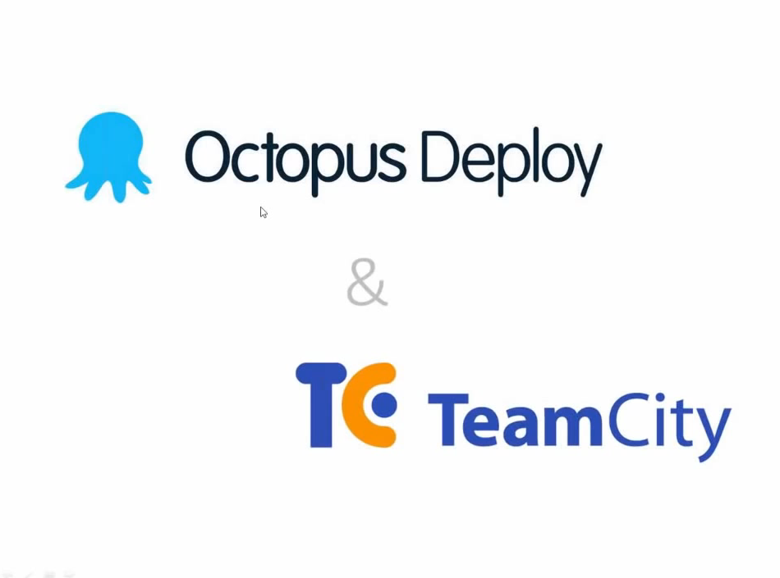

**Installation instructions** [**http://docs.octopusdeploy.com/display/OD/TeamCity**](http://docs.octopusdeploy.com/display/OD/TeamCity)

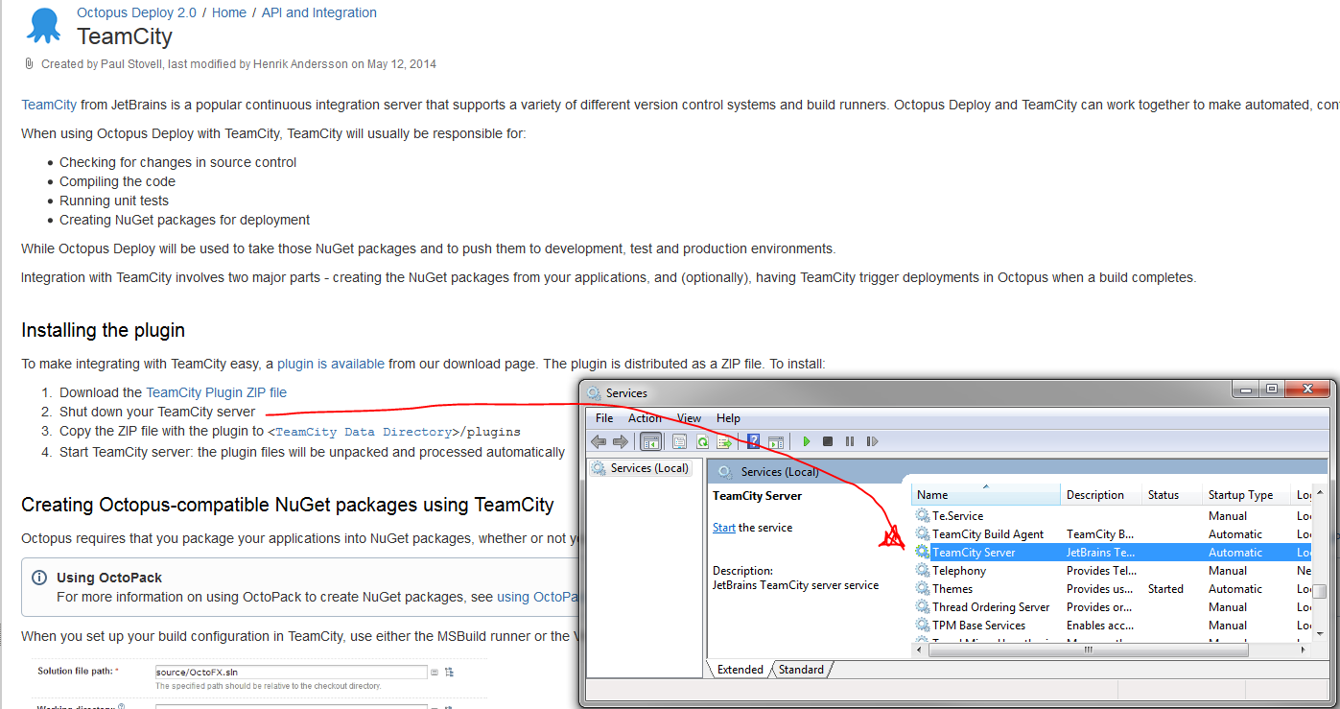

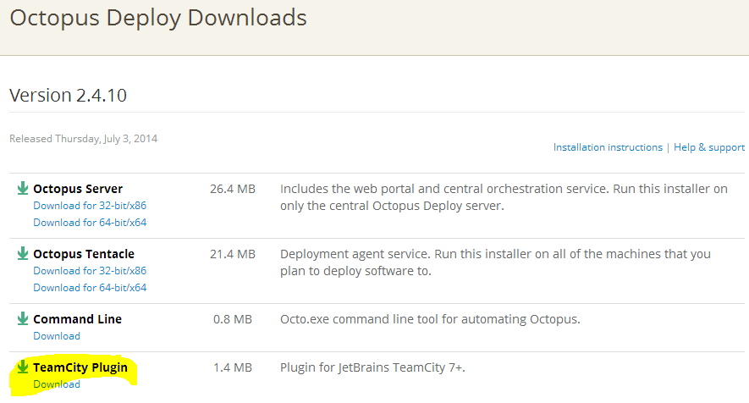

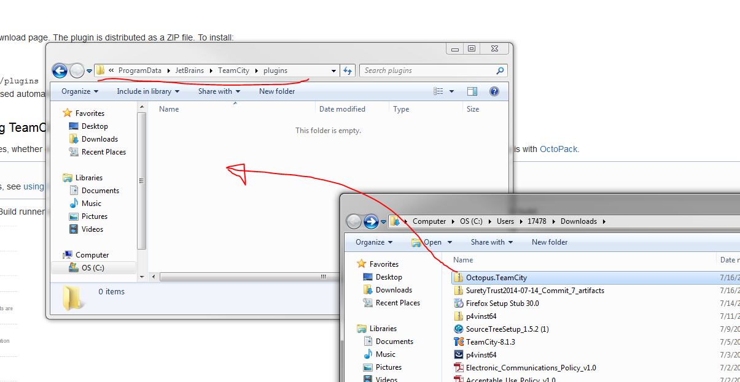

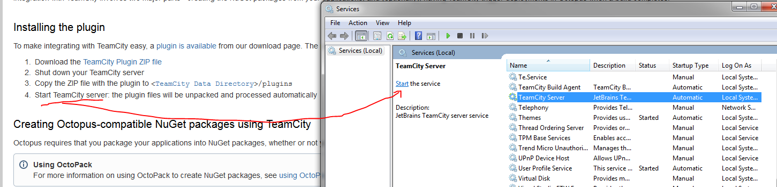

# Vid @5.50 Deployment Automation with Octopus Deploy and TeamCity <http://www.youtube.com/watch?v=JWGLEEm9Qhg>

# 

Octopus requires that you package your applications into NuGet packages. You can package anything into a Nuget package, or you can use OctoPack, which strips out all files not necessary for deployment. OctoPack only works with MSBuild, and is ideal for .Net Web App deployments.

**You can install OctoPack through the UI or by the console shown a little later below. Only on projects being deployed like the web project or a web service**

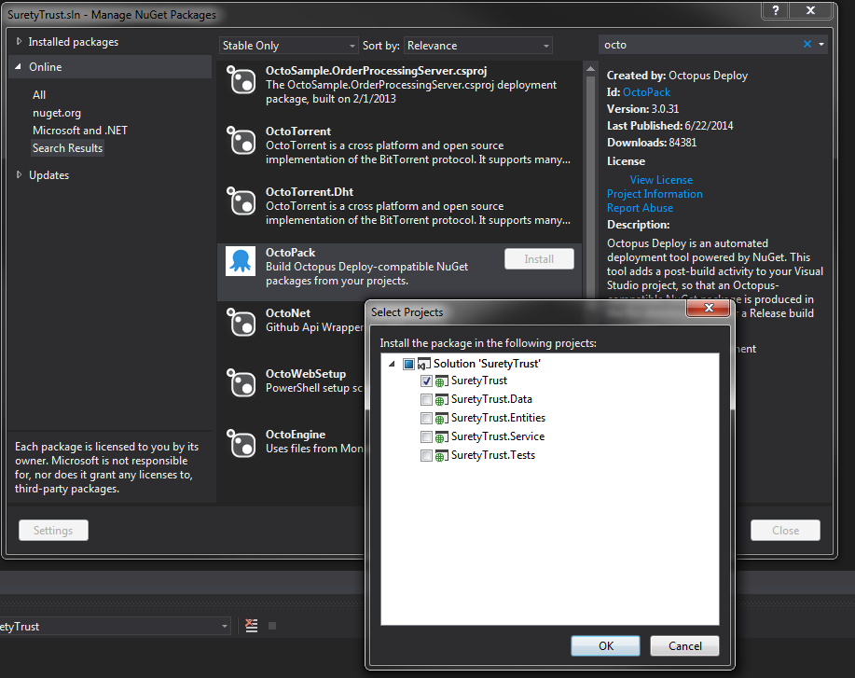

**Creating Octopus-compatible NuGet packages using TeamCity**

The **OctoPack package version** setting should evaluate to a version number with multiple parts (e.g., **1.3.7**). It cannot be a single number. You may want to edit the General Settings for your project to ensure that the TeamCity build number uses multiple parts:

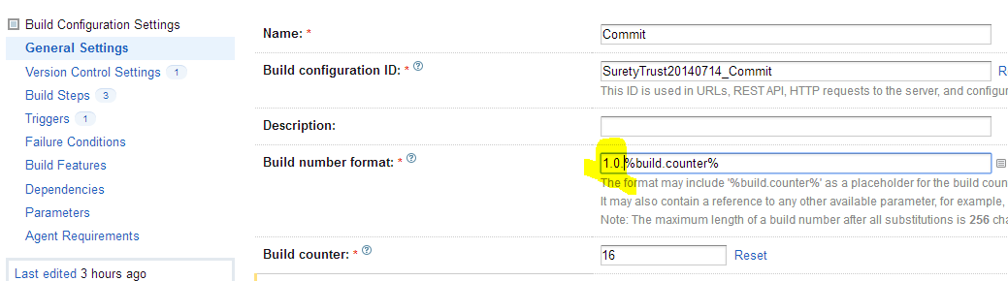

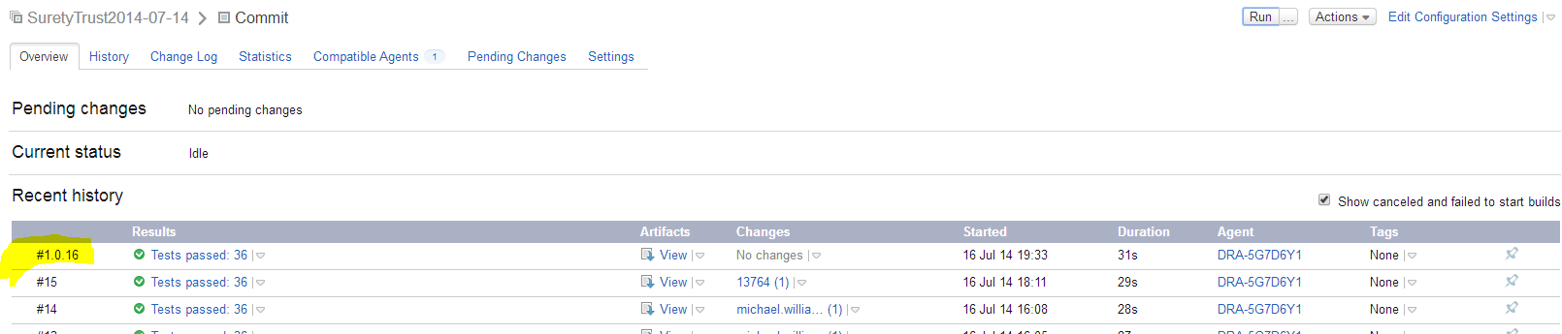

When you set up your build configuration in TeamCity, use either the MSBuild runner or the Visual Studio build runner. At the bottom of the runner settings, you'll see some options to run OctoPack during the build:

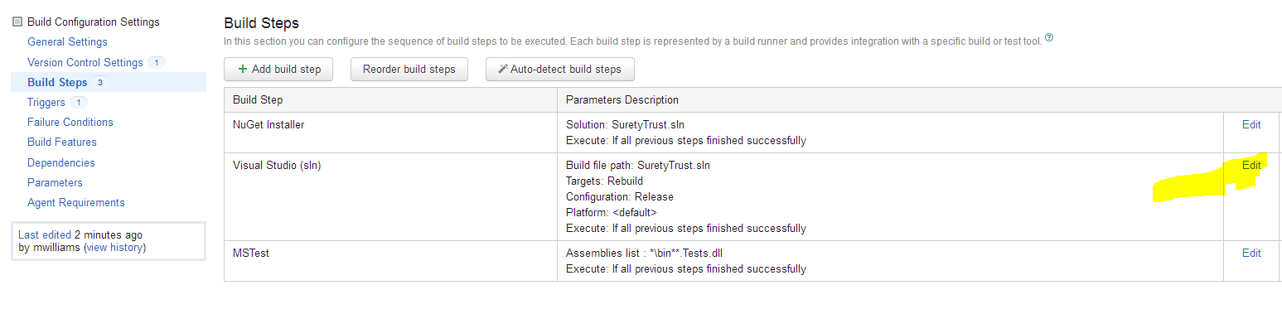

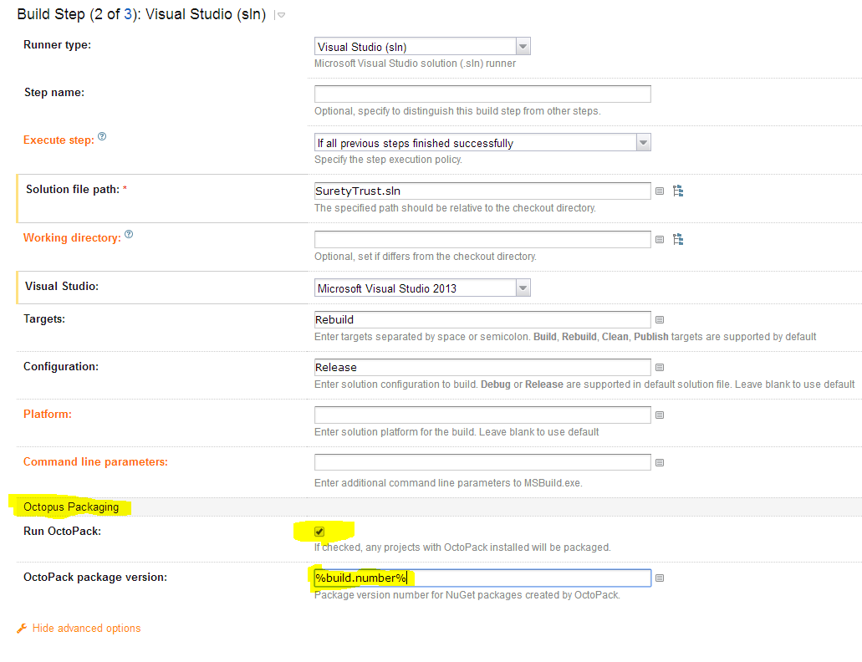

With these options selected, NuGet packages will automatically be created using the version number of the current build. OctoPack will ensure that these packages appear in the artifacts tab of TeamCity, so take out artifact paths like below

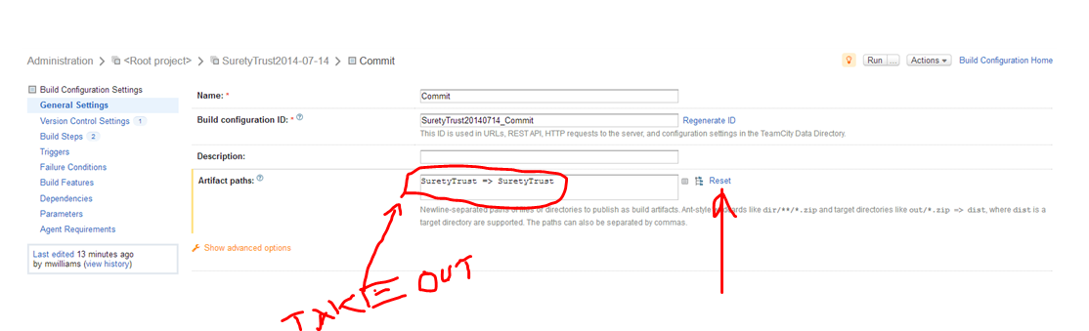

**!!! HAVE TO COMMIT & PUSH OctoPack installation to GIT !!!**

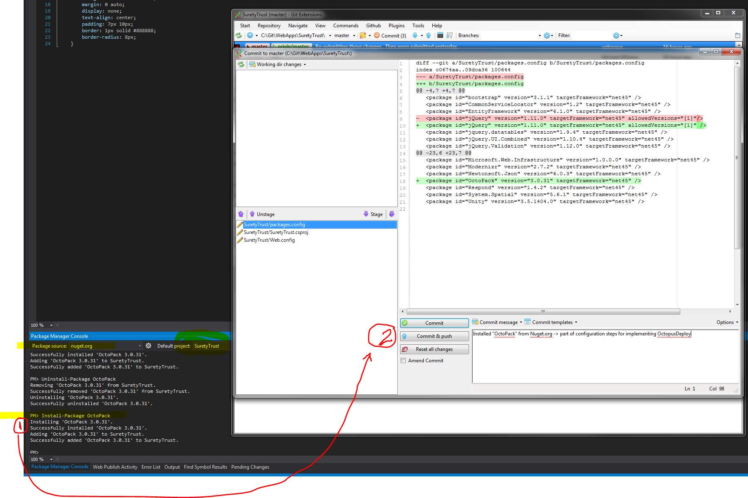

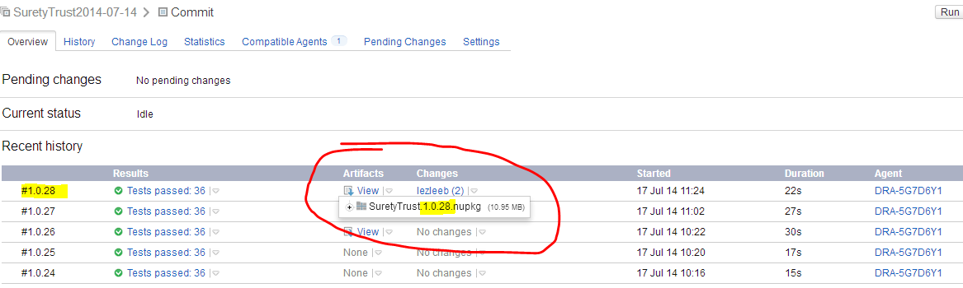

**Setup parameters for custom build (optional)**

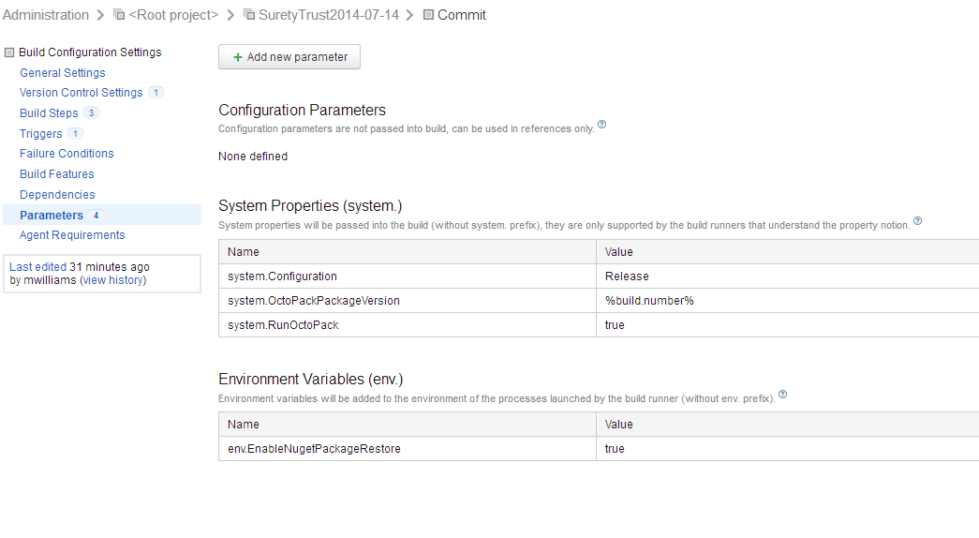

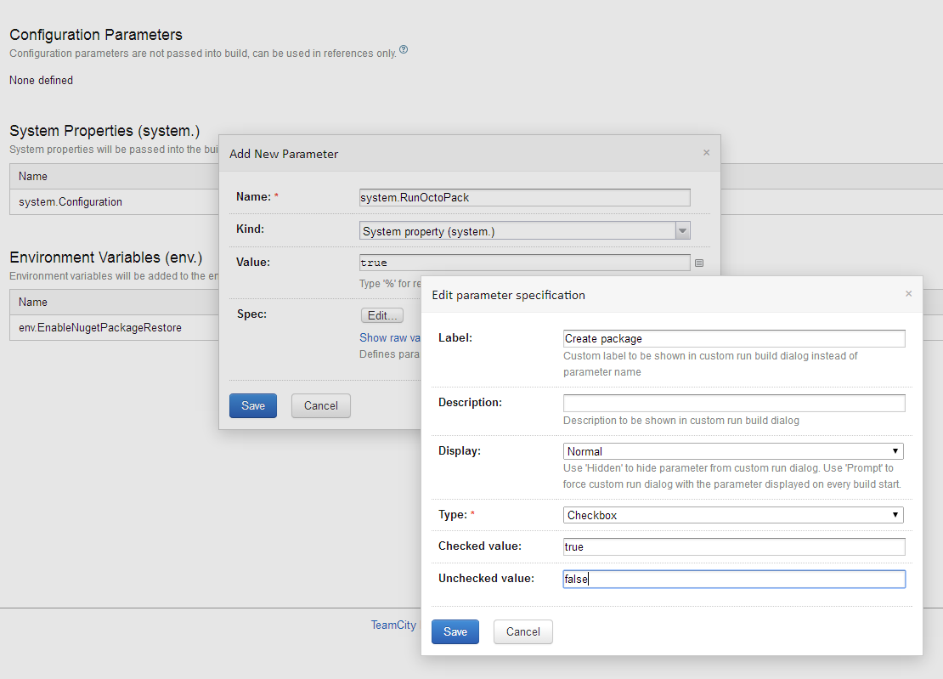

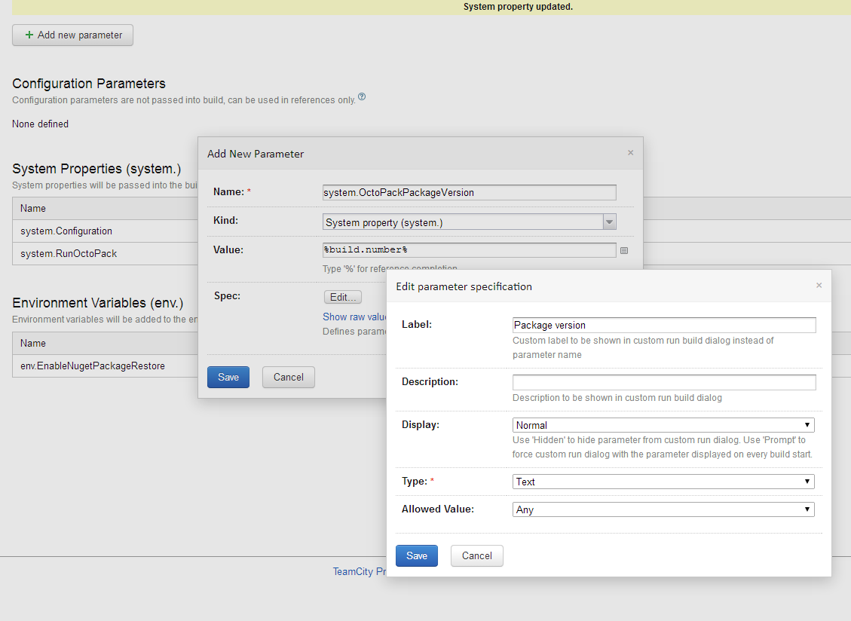

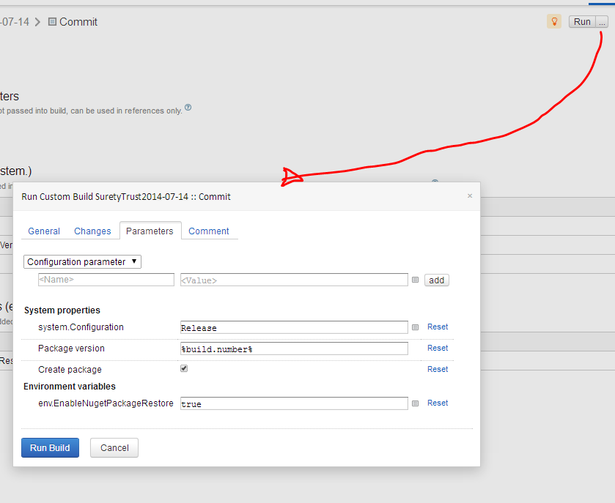

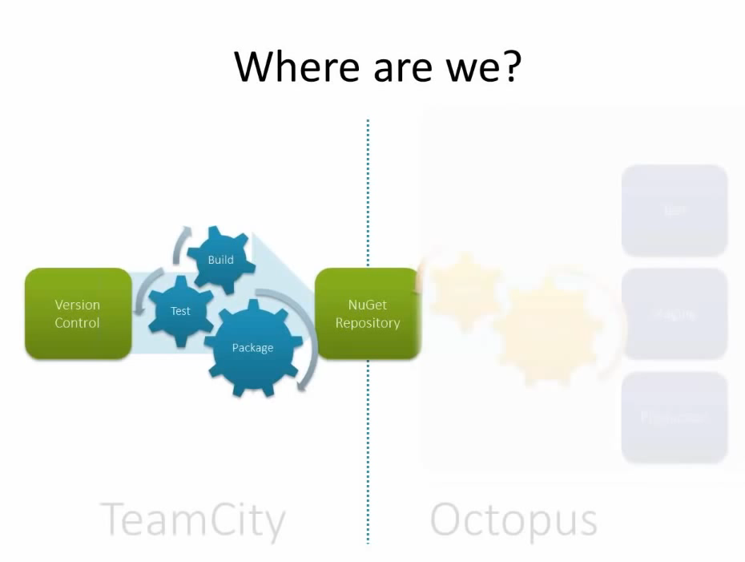

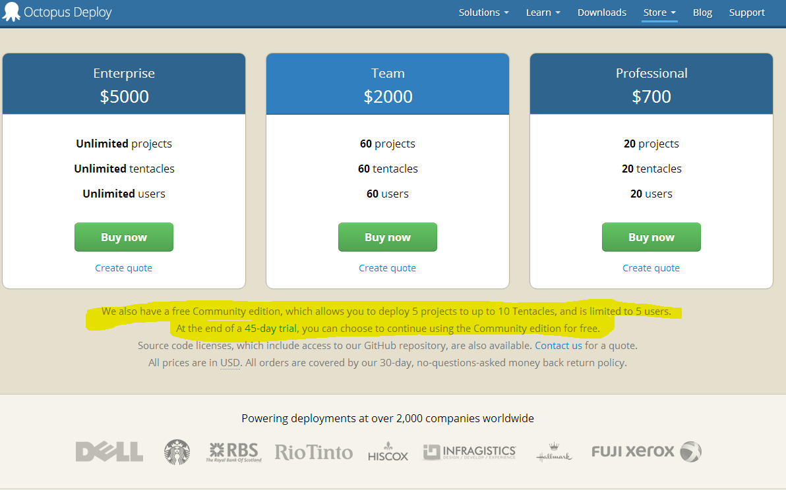

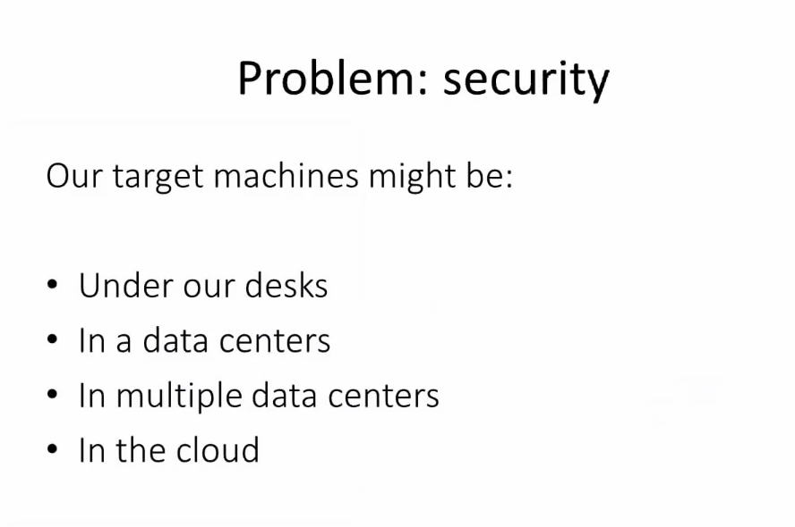

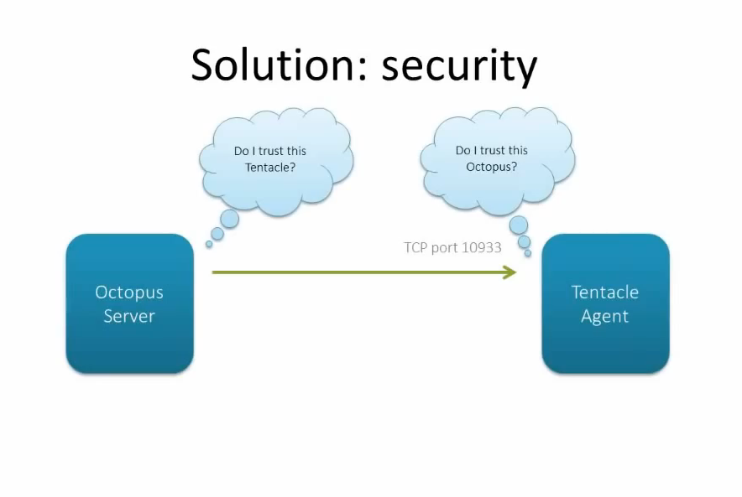

**Setting up two-way trust relationship with private keys**

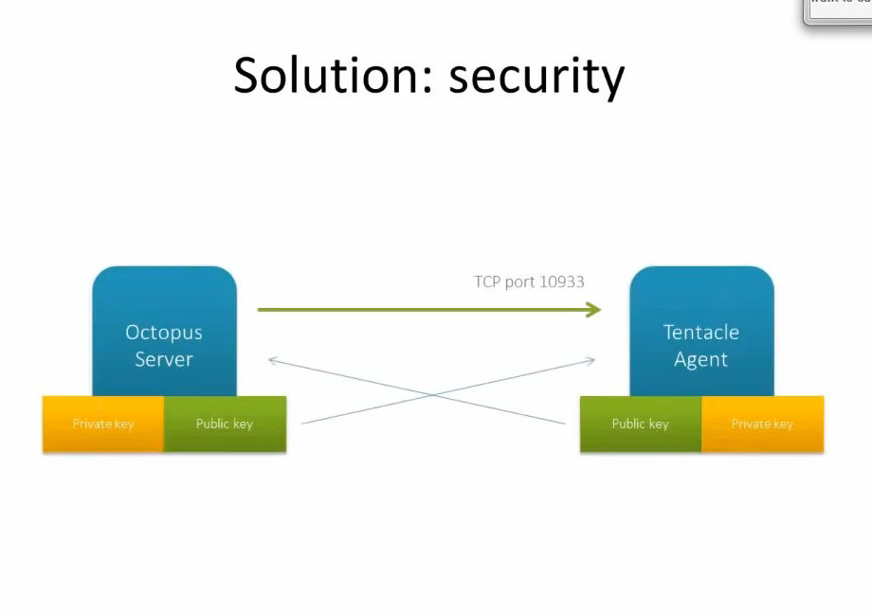

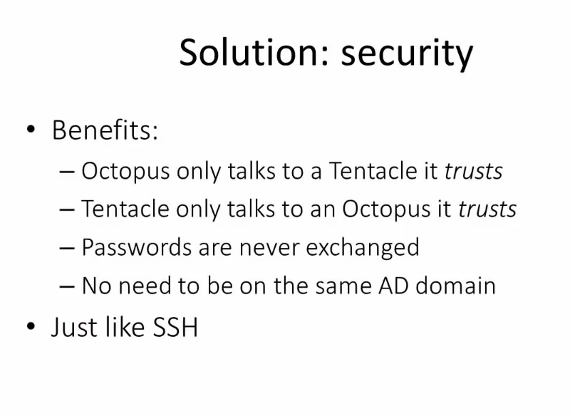



[**http://docs.octopusdeploy.com/display/OD/Installing+Octopus**](http://docs.octopusdeploy.com/display/OD/Installing+Octopus)

[**http://docs.octopusdeploy.com/display/OD10/TeamCity+Integration**](http://docs.octopusdeploy.com/display/OD10/TeamCity+Integration)

[**http://docs.octopusdeploy.com/display/OD/TeamCity**](http://docs.octopusdeploy.com/display/OD/TeamCity)

**After installing…**

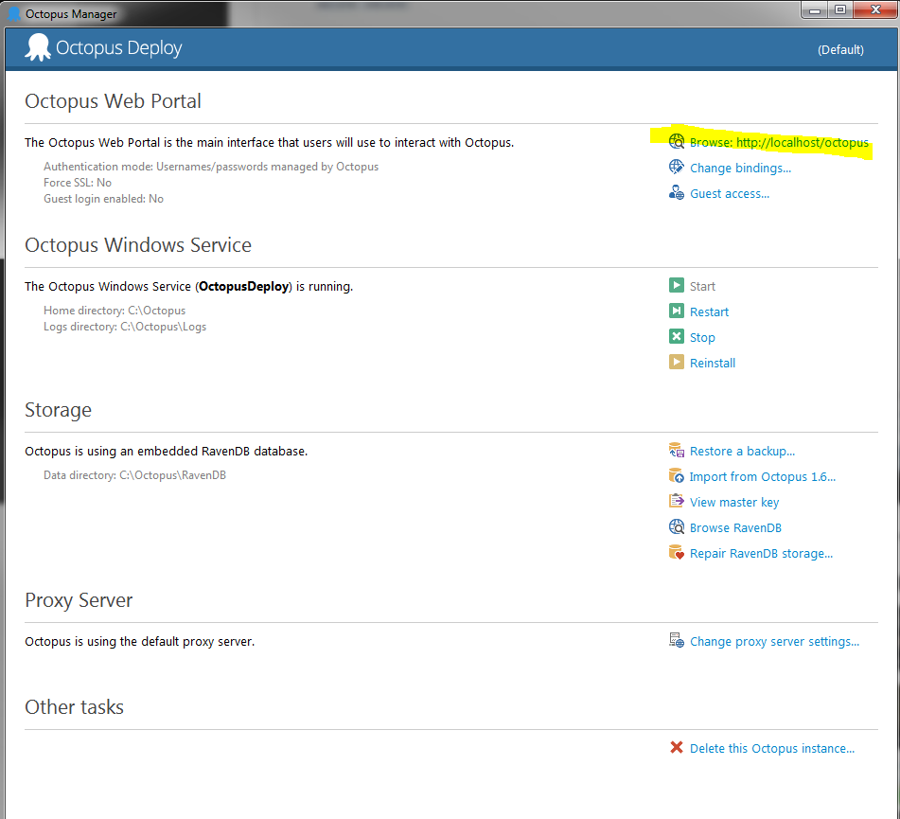

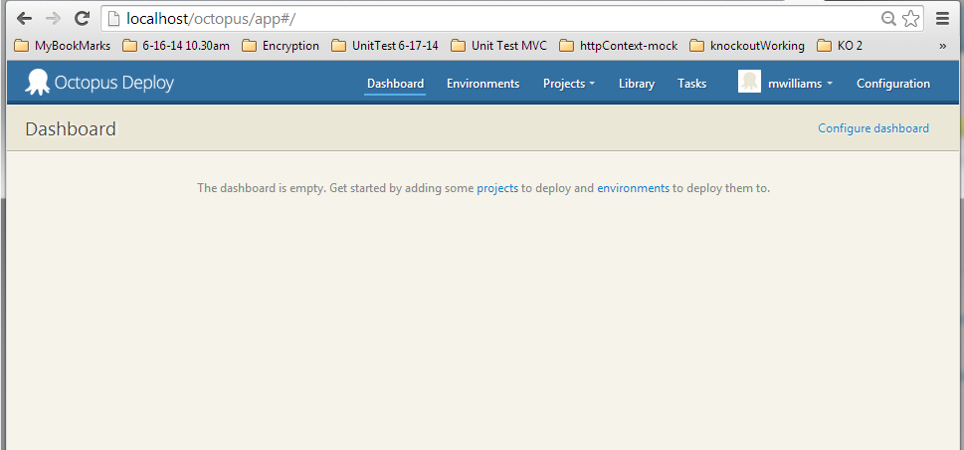

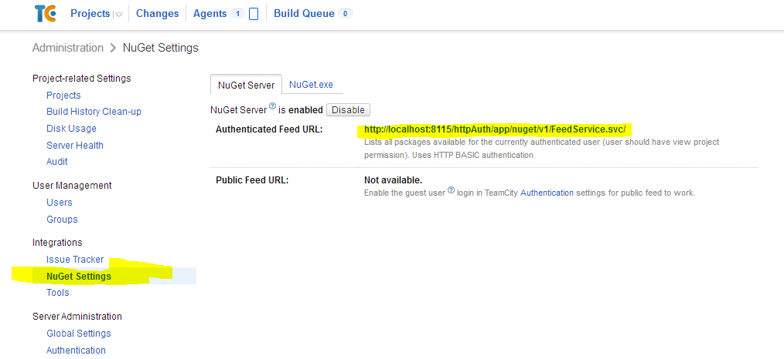

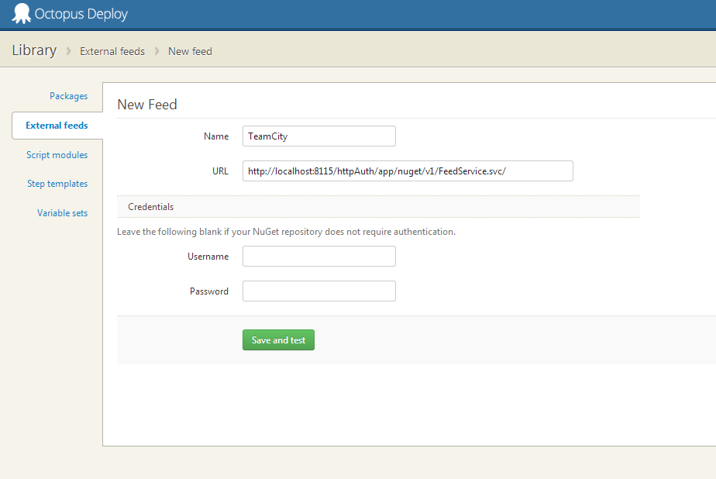

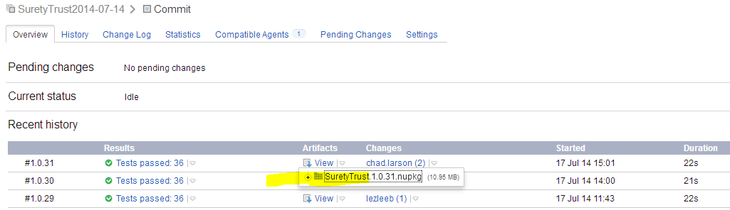

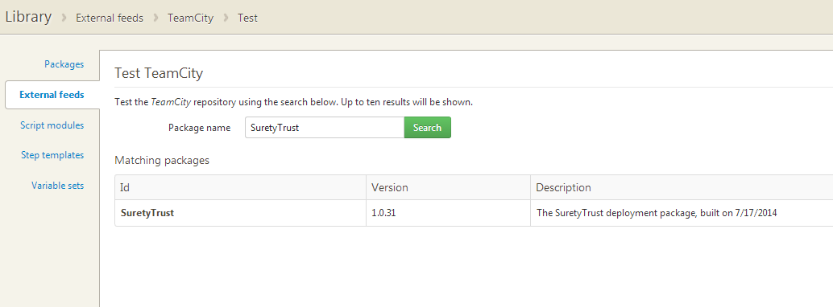

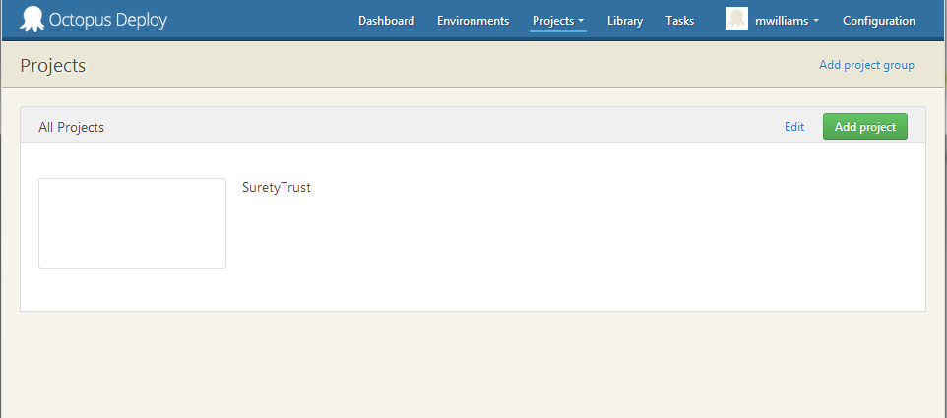

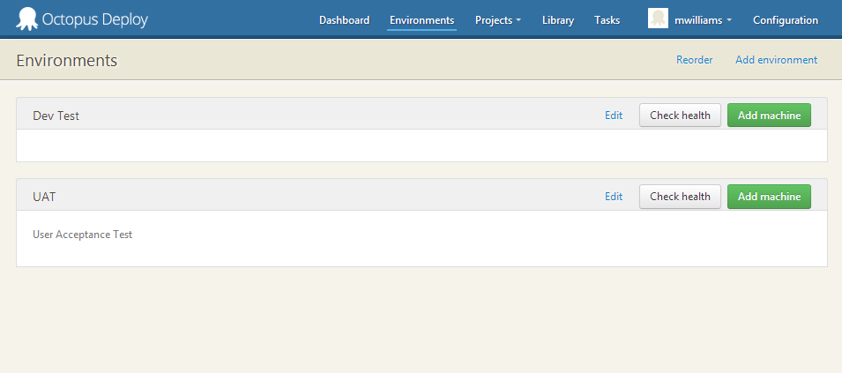

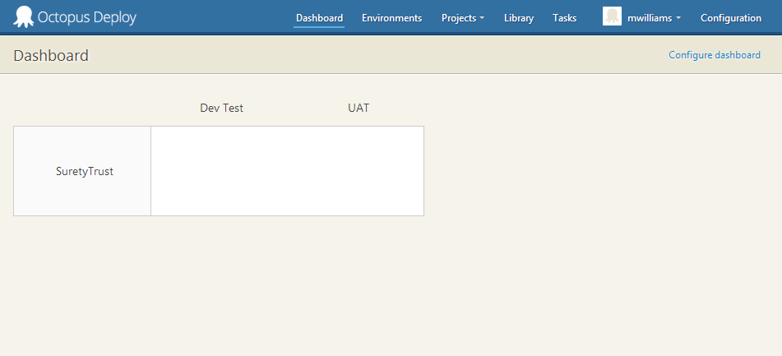

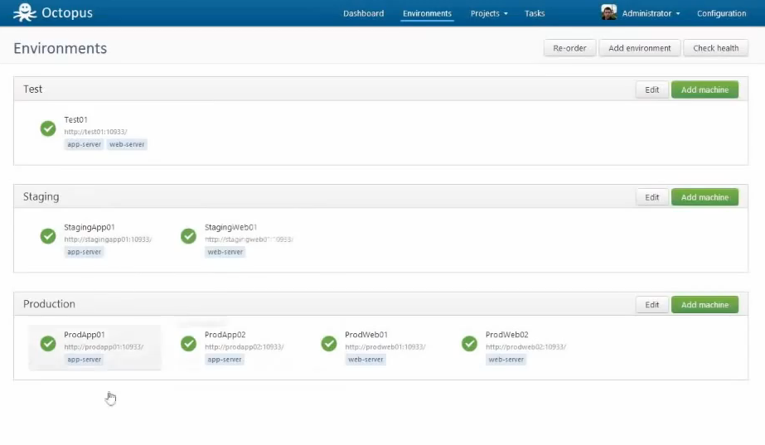

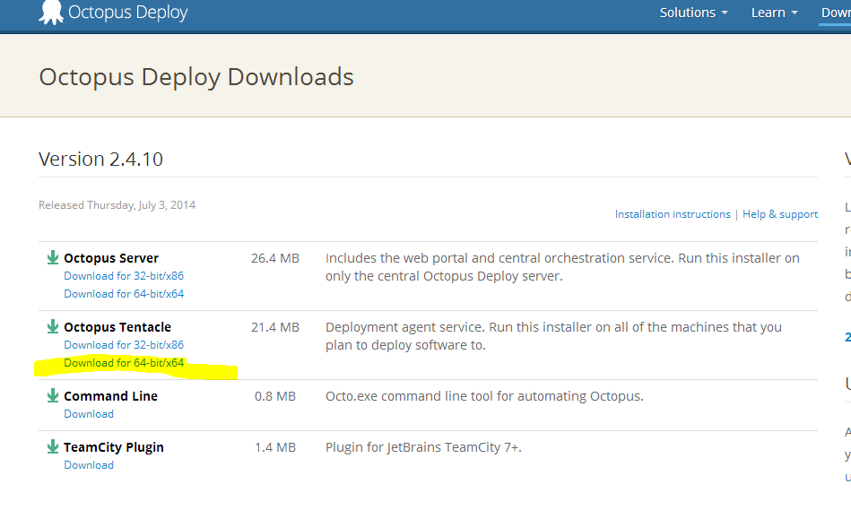

[**http://docs.octopusdeploy.com/display/OD/Listening+Tentacles**](http://docs.octopusdeploy.com/display/OD/Listening+Tentacles)

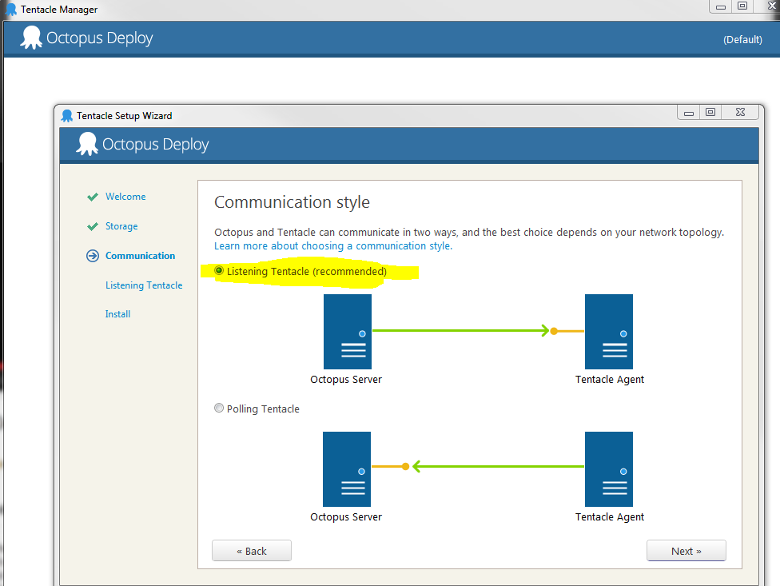

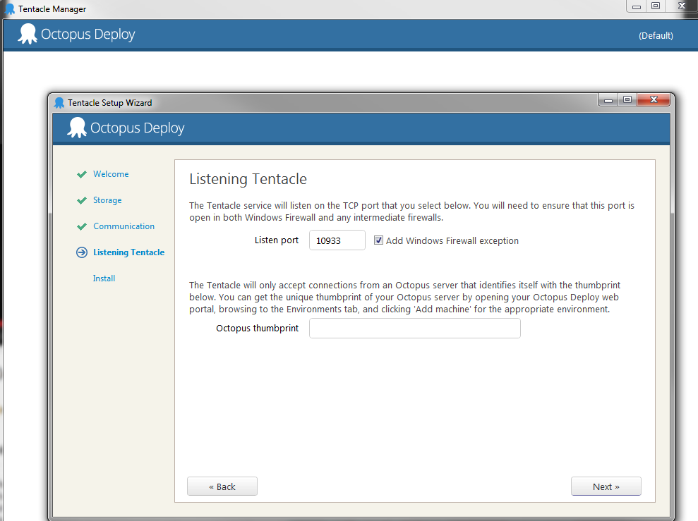

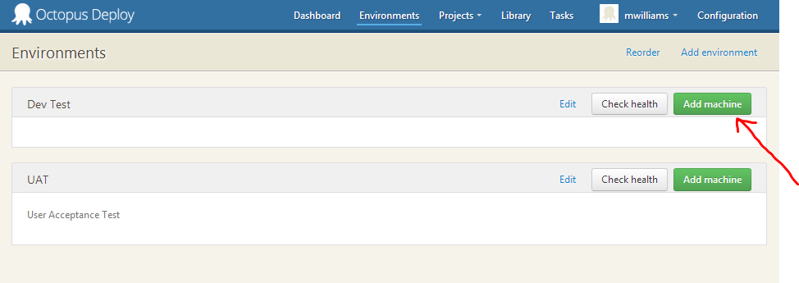

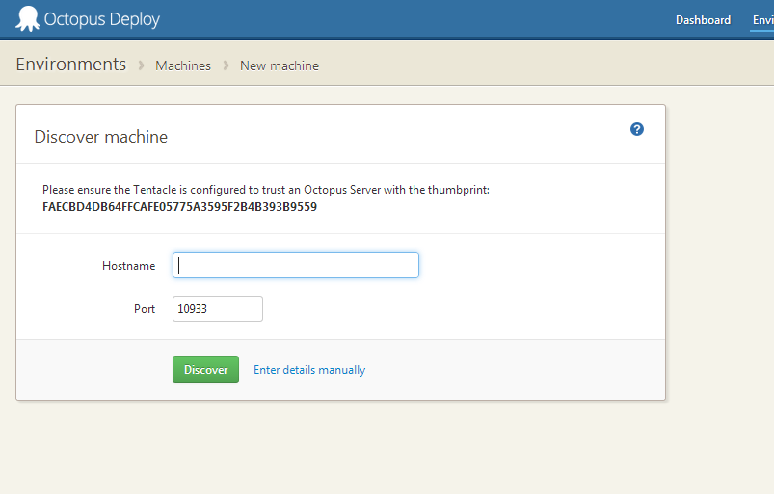

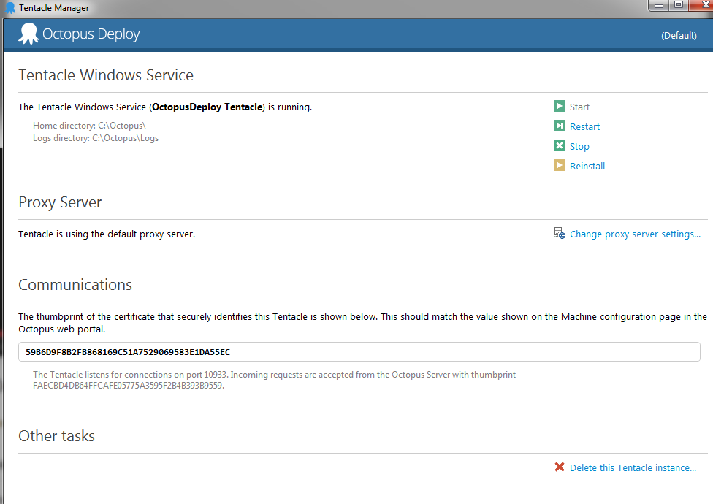

**GET HOSTNAME FOR OCTOPUS DEPLOY TO DISCOVER IT**

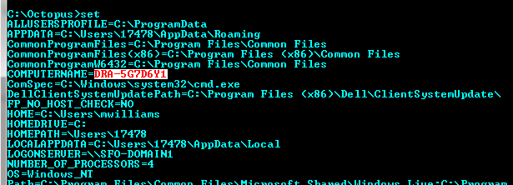

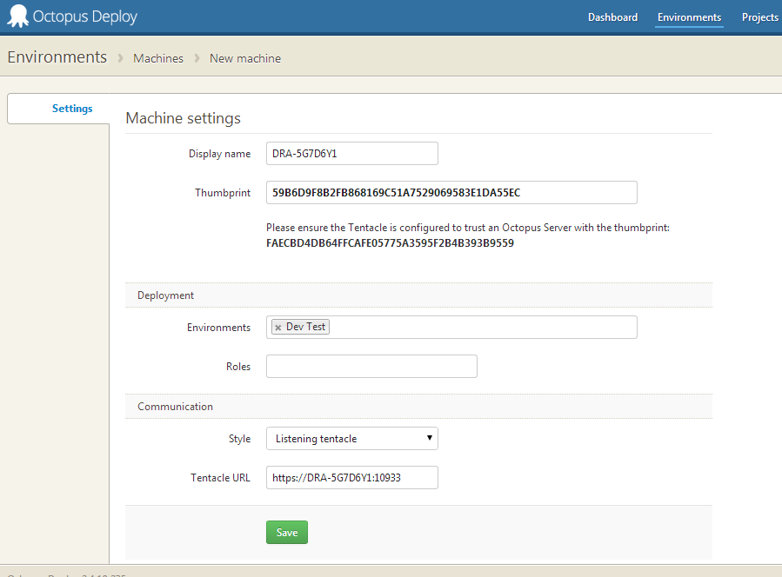

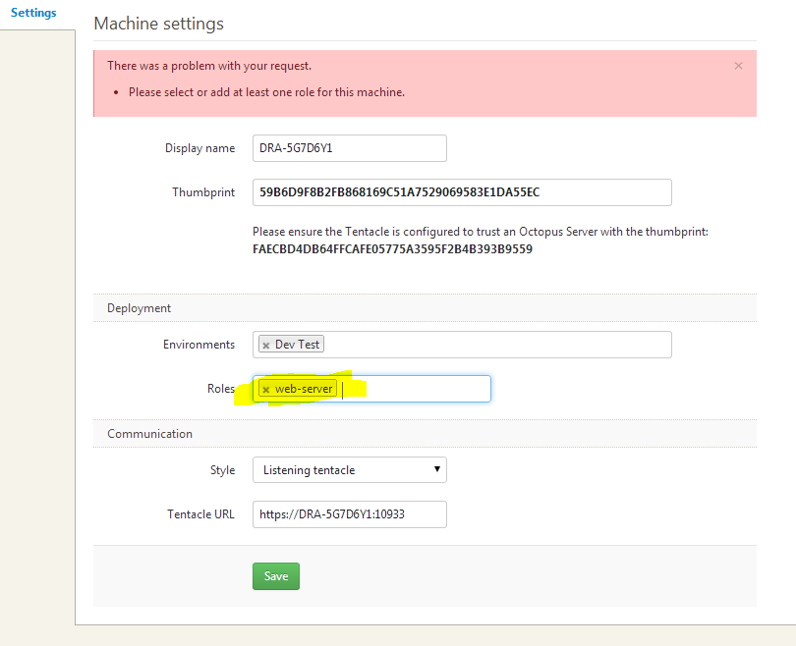

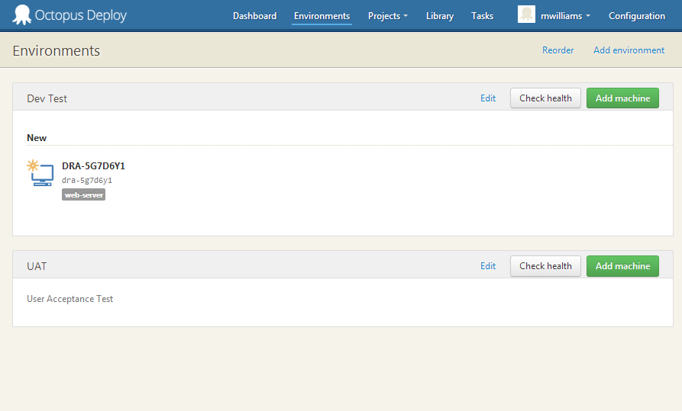

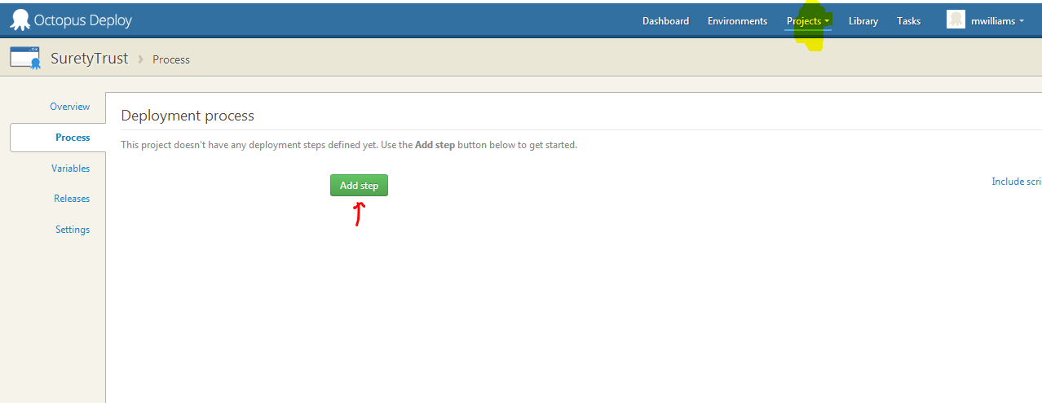

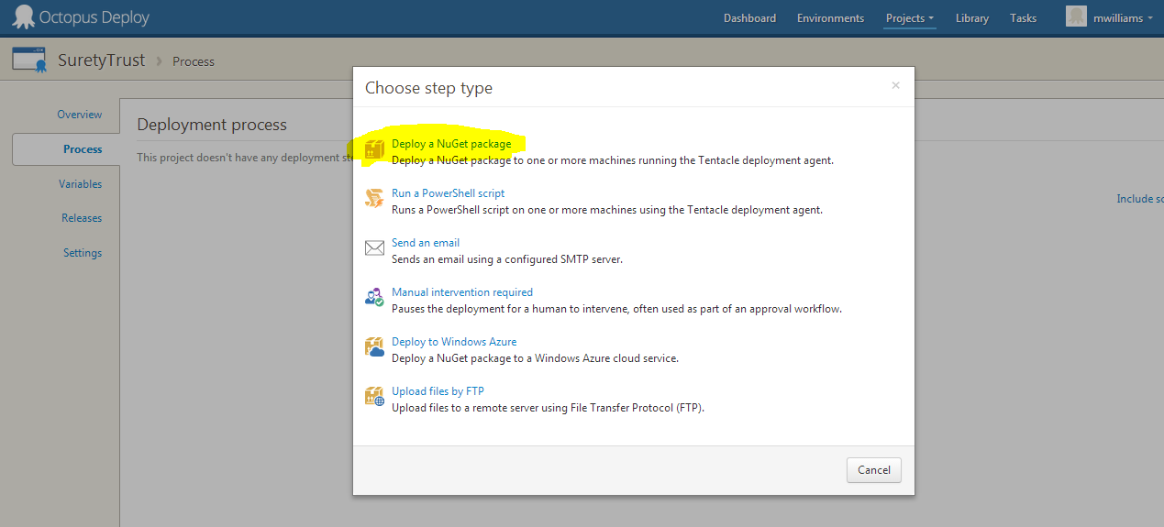

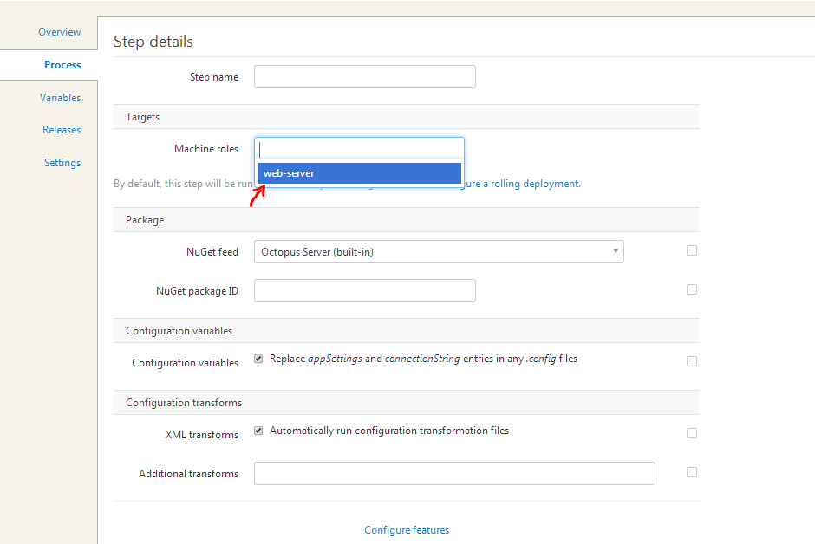

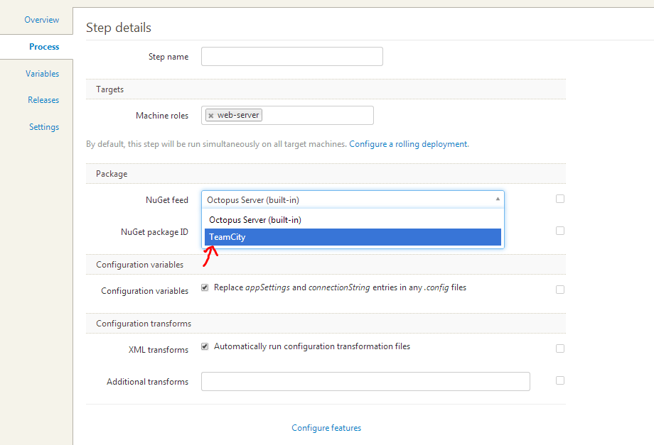

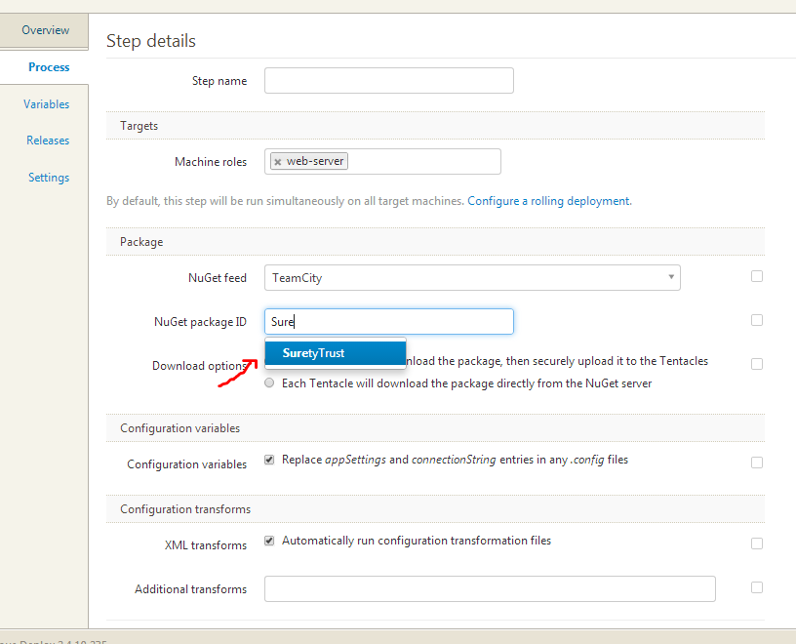

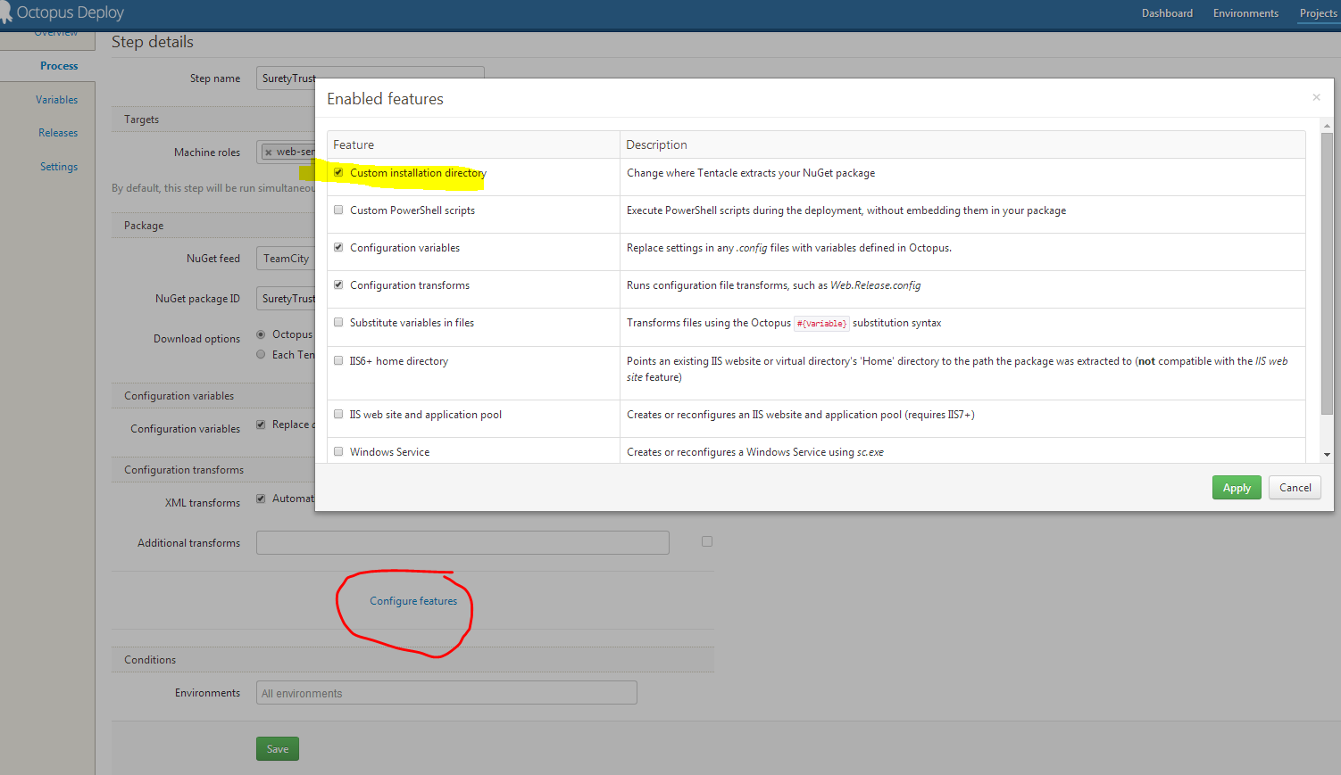

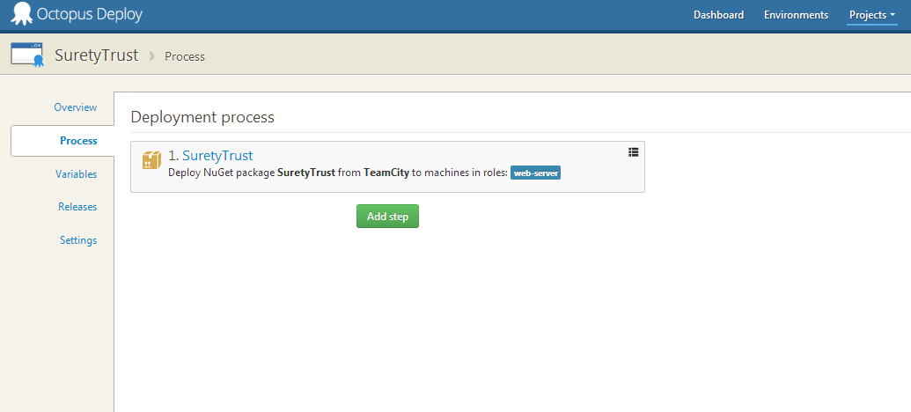

**SHOW how IIS is configured for the directory below**

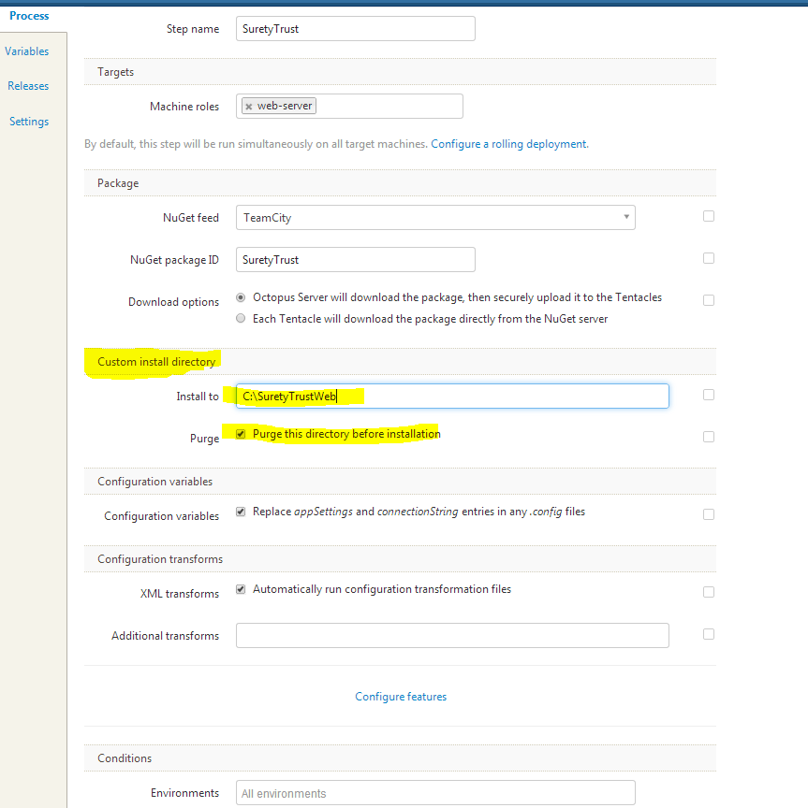

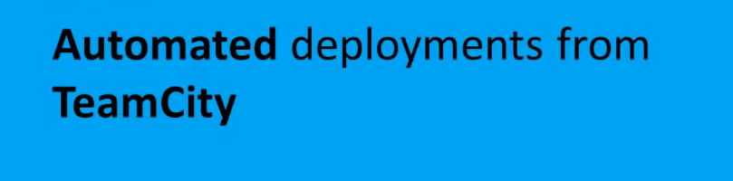

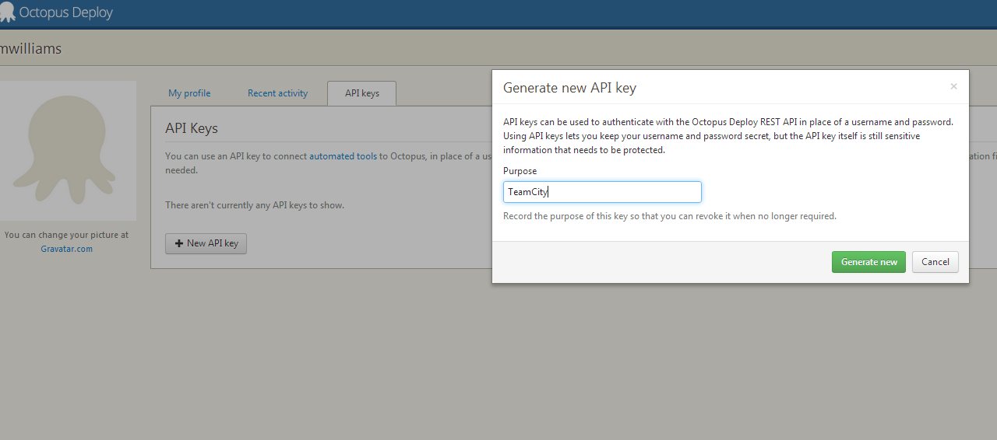

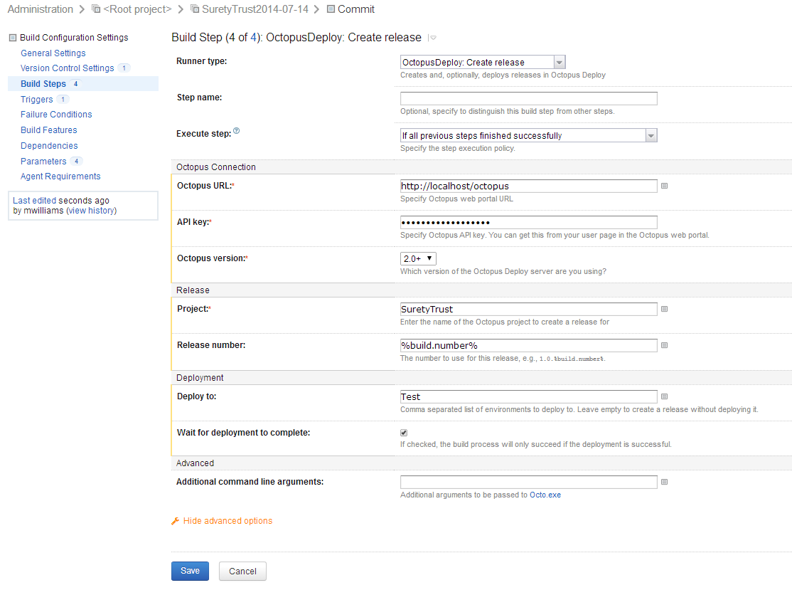

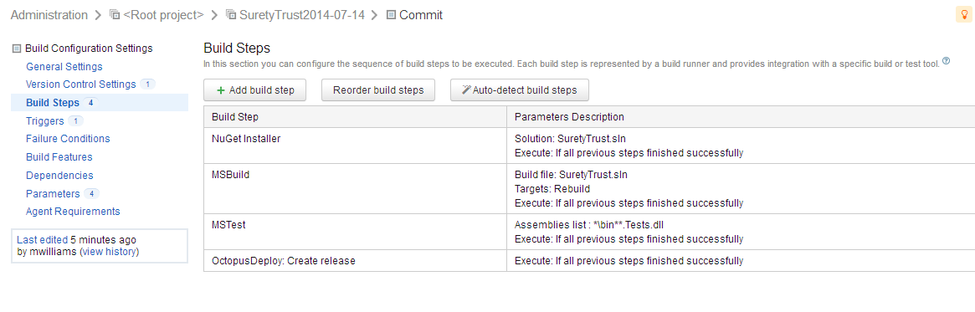

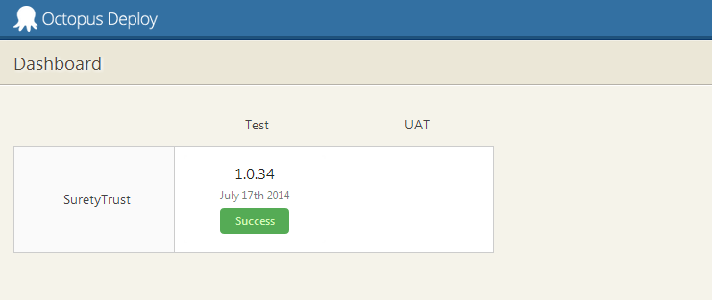

**NEEDS TO BE SET UP talked about on vid @ 1.01.00**

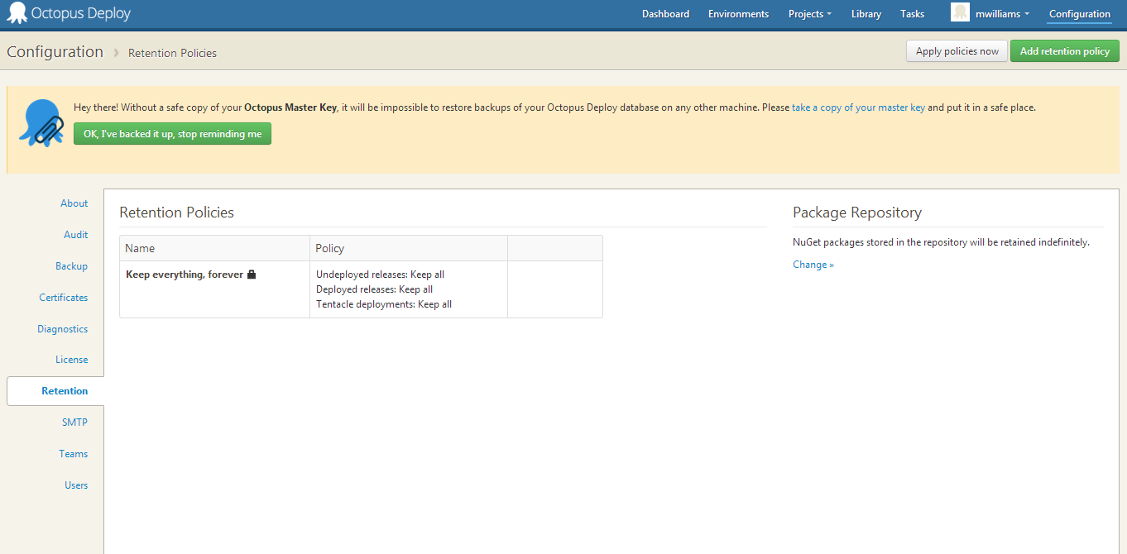

**For Octopus Deploy to not be a build behind, you have to configure TC like the following:**

Create two build configurations in TeamCity, one to build and one to deploy with Octopus.

NuGet packages created from your build won't appear in TeamCity until after the build completes. This means you'll usually need to configure a secondary build configuration, and use a snapshot dependency and build trigger in TeamCity to run the deployment build configuration after the first build configuration completes.

So create 2 build configurations, then setup a snapshot dependency from the build to the deploy config and also a trigger to kick off the deploy after a successful build. See the [vid](http://www.youtube.com/watch?v=JWGLEEm9Qhg) @ 29.20 for how to do this (the video says to use Deploy Release Runner DON’T DO THAT! Use Create Release Runner

1. **Create Another Build in the project -> Deploy to Test**
2. **Don’t configure VC settings**
3. **Add the following Build Step; get API key from Octopus admin profile**

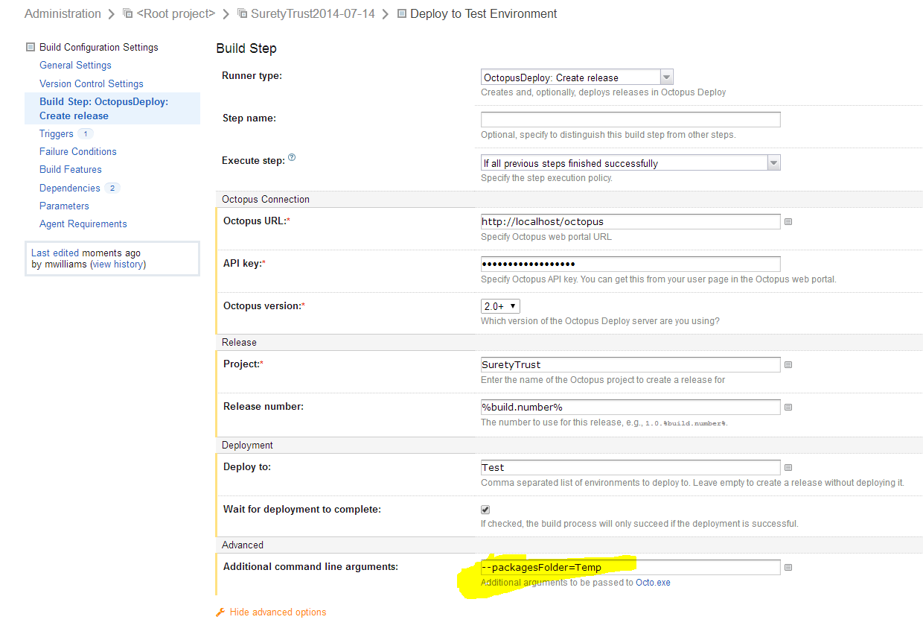

**Octo.exe documentation** [**http://docs.octopusdeploy.com/display/OD/Creating+releases**](http://docs.octopusdeploy.com/display/OD/Creating+releases)

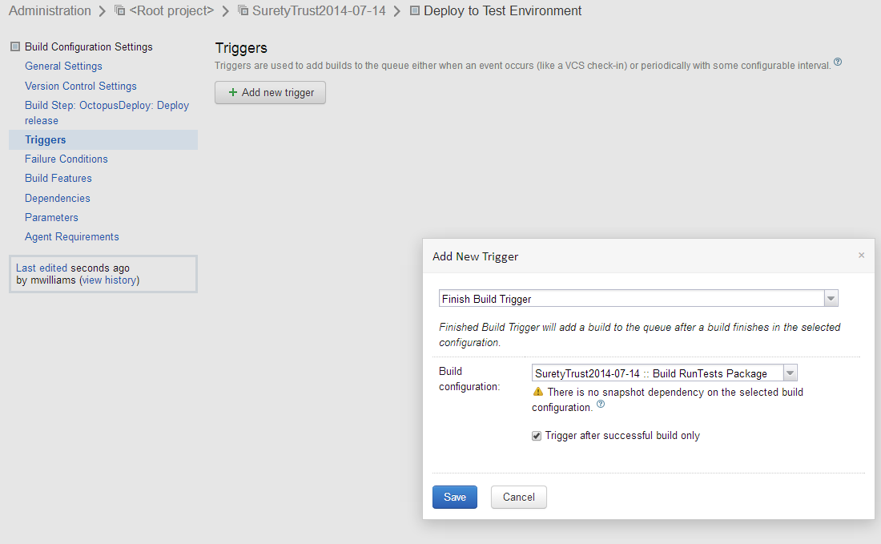

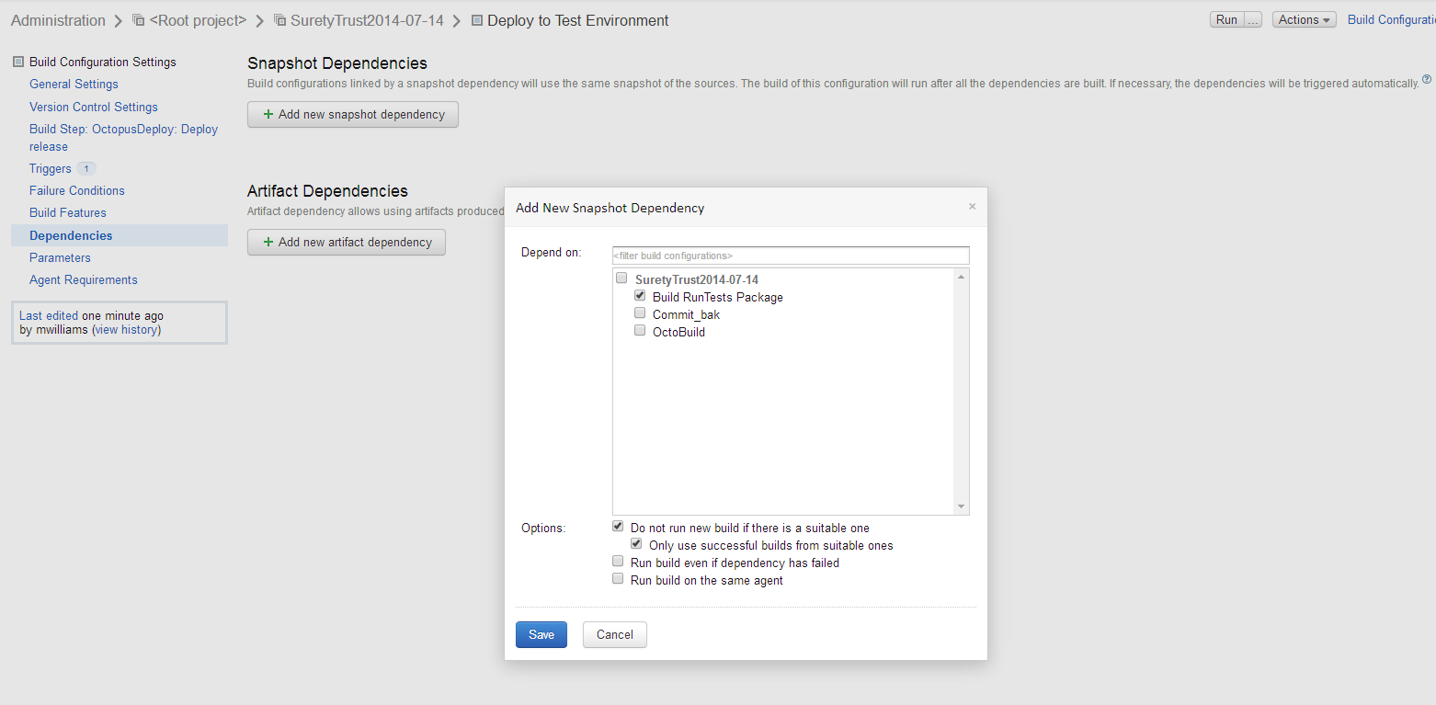

**Change build # format to depency’s build # -> hit the icon on the right of that field to find it**

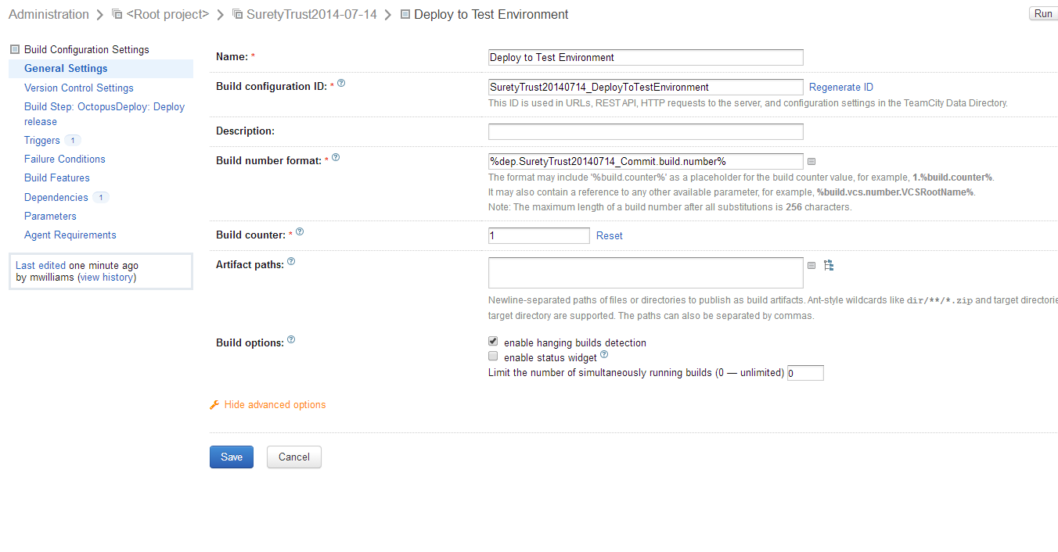

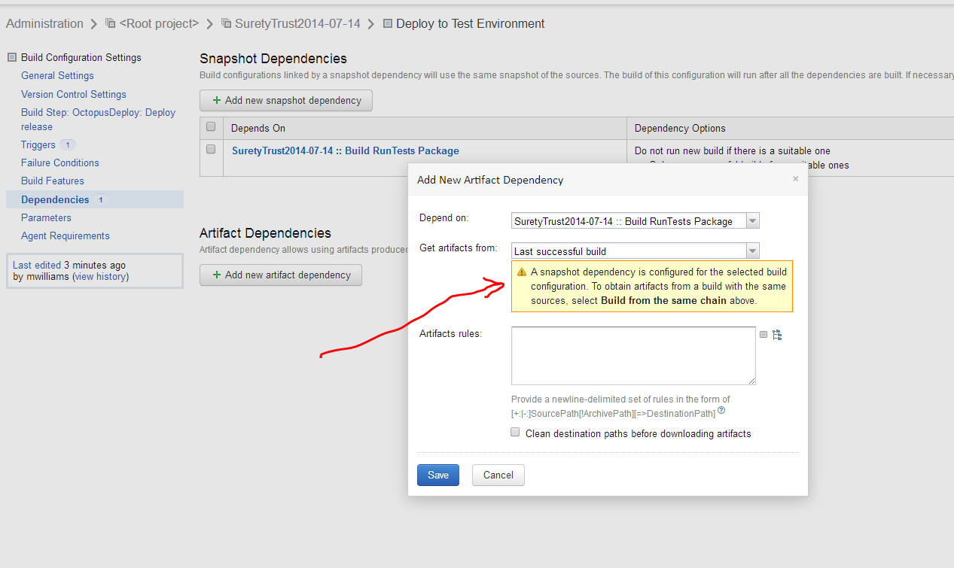

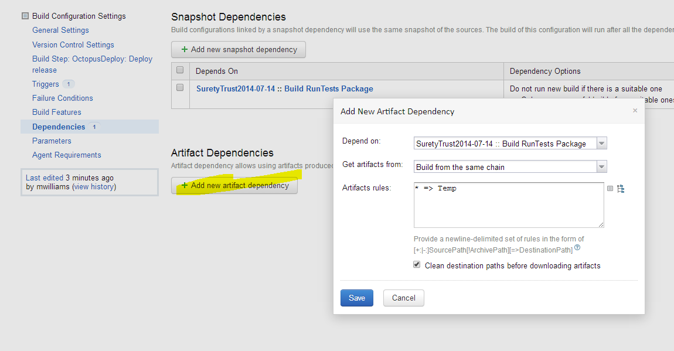

* => Temp This says take whatever NuGet packages were produced and put them in a folder called Temp

**Create Failure Condition in case Octopack gets in a bad state and Artifacts are no longer being created**

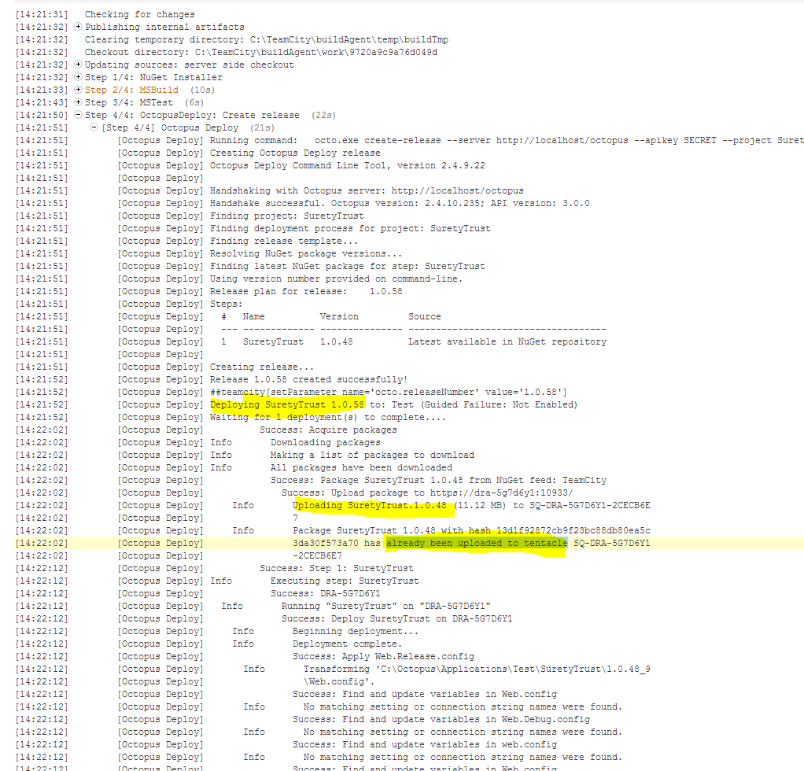

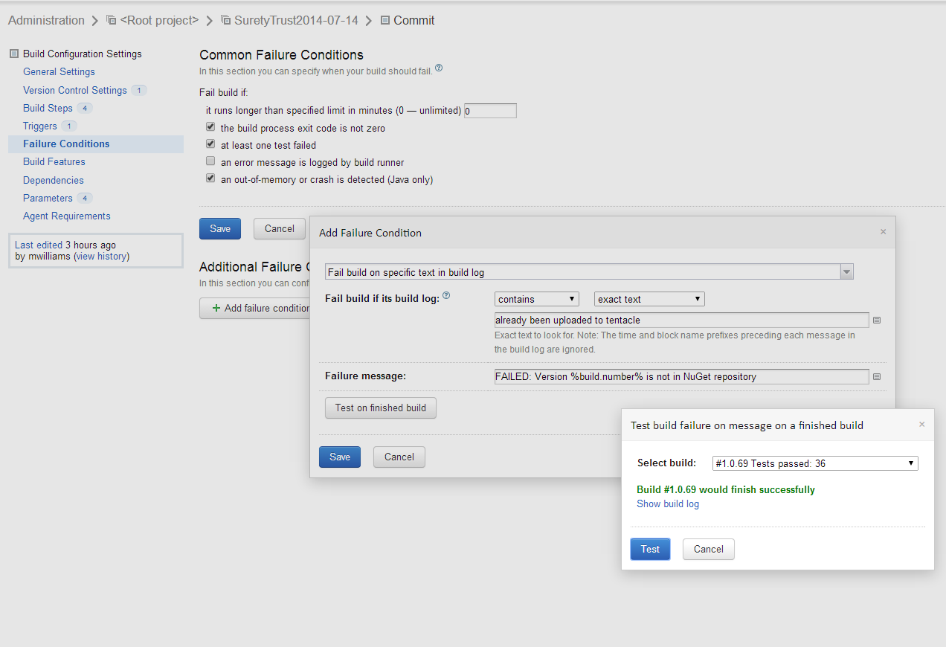

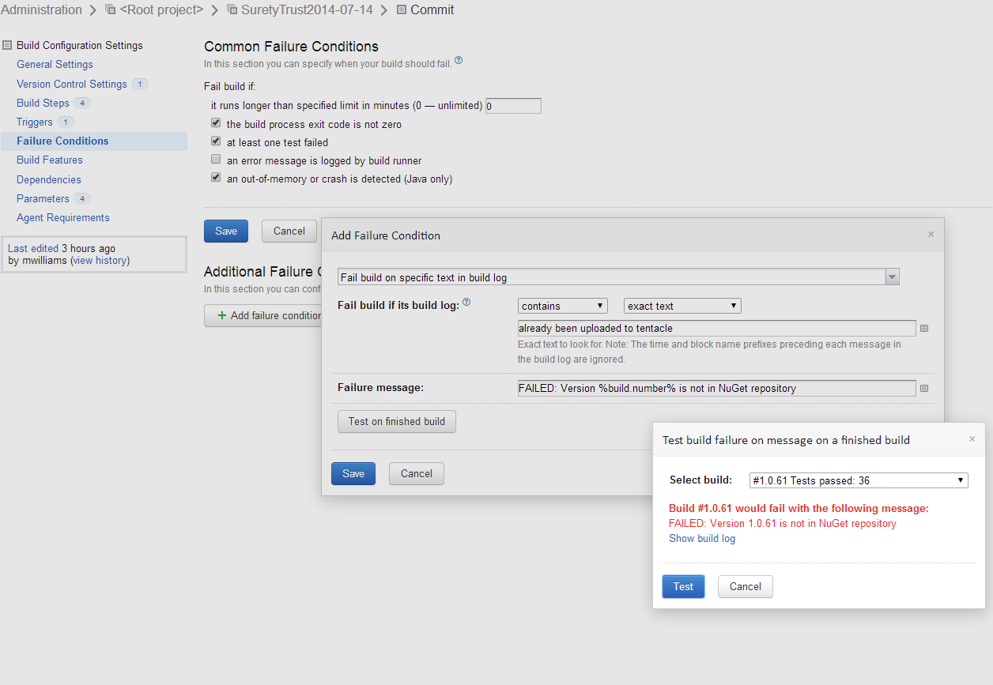

**ADD PowerShell Script Steps to Deploy Process**

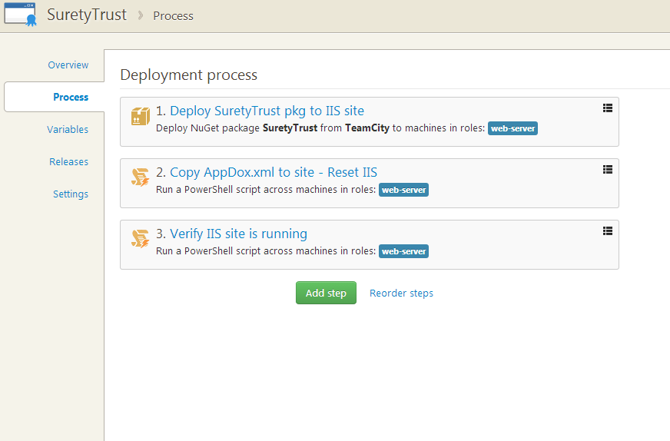

**For Reference “Deploy SuretyTrust pkg to IIS site step:**

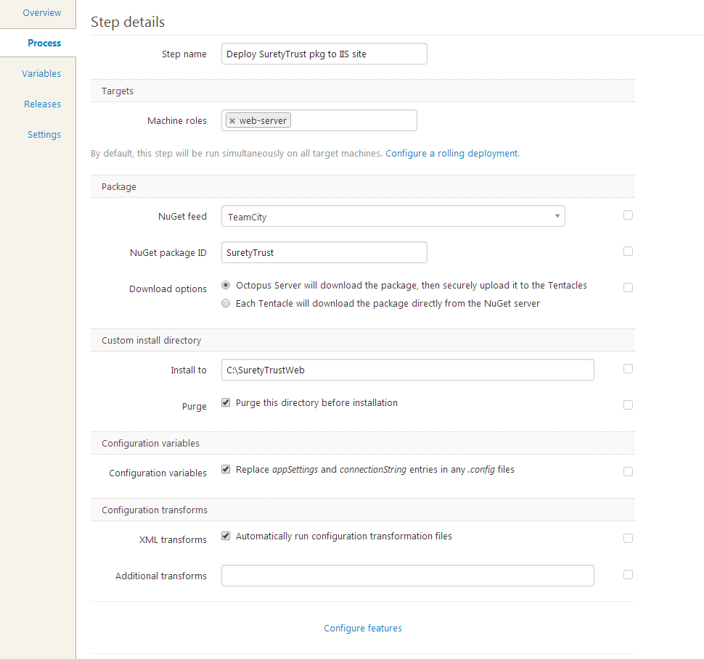

**Add the Following to the script area in pic below**

md C:\SuretyTrustWeb\App_Data -Force

Copy-Item -Path C:\Git\WebApps\SuretyTrust\SuretyTrust\App_Data\AppDox.xml -Destination C:\SuretyTrustWeb\App_Data\AppDox.xml

Invoke-Command -ScriptBlock {iisreset /STOP}

Invoke-Command -ScriptBlock {iisreset /START}

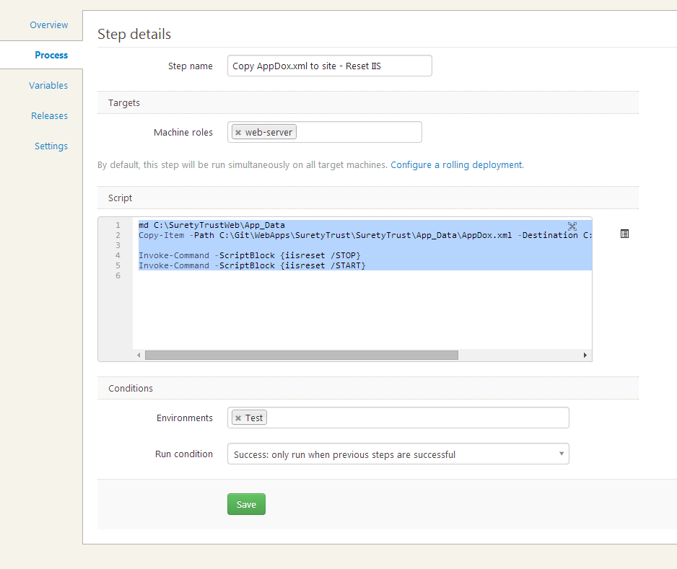

**Add Following to another PowerShell Script step:** CAUTION SOME THINGS WORK IN WINDOWS POWERSHELL BUT NOT IN OCTOPUS DEPLOY POWERSHELL

( I sent mail to OctopusDeploy about this)

try {

$HTTP_Request = [System.Net.WebRequest]::Create('http://localhost')

$HTTP_Response = $HTTP_Request.GetResponse()

}

catch [Exception]

{

# !!! exception is expected !!!

write-host $_.Exception.Message;

if ($_.Exception.Message -ne "The remote server returned an error: (500) Internal Server Error.")

{

throw $_.Exception.Message

}

}

# (works in WindowsPowerShell But Not OctoDeploy) -> $HTTP_Response.Close()

# (works in WindowsPowerShell But Not OctoDeploy) -> $HTTP_Status = [int]$HTTP_Response.StatusCode

# (works in WindowsPowerShell But Not OctoDeploy) -> write-host $HTTP_Status

# (works in WindowsPowerShell But Not OctoDeploy) -> If ($HTTP_Status -eq 200)

# (works in WindowsPowerShell But Not OctoDeploy) -> {

# (works in WindowsPowerShell But Not OctoDeploy) -> Write-Host "Site is OK!"

# (works in WindowsPowerShell But Not OctoDeploy) -> }

# (works in WindowsPowerShell But Not OctoDeploy) -> Else {

# (works in WindowsPowerShell But Not OctoDeploy) -> throw "HTTP_Response.StatusCode IS NOT 200 -> value is -> " + $HTTP_Status

# (works in WindowsPowerShell But Not OctoDeploy) -> }

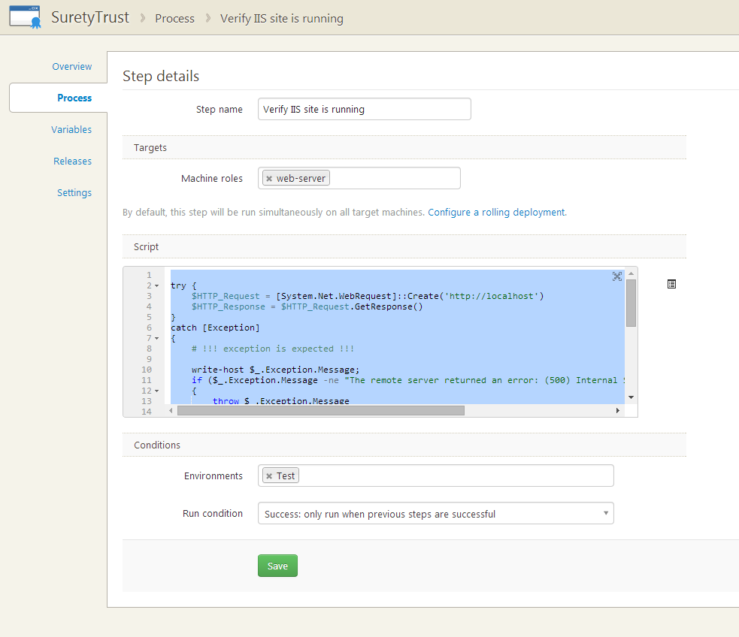

**Testing a powershell script:**

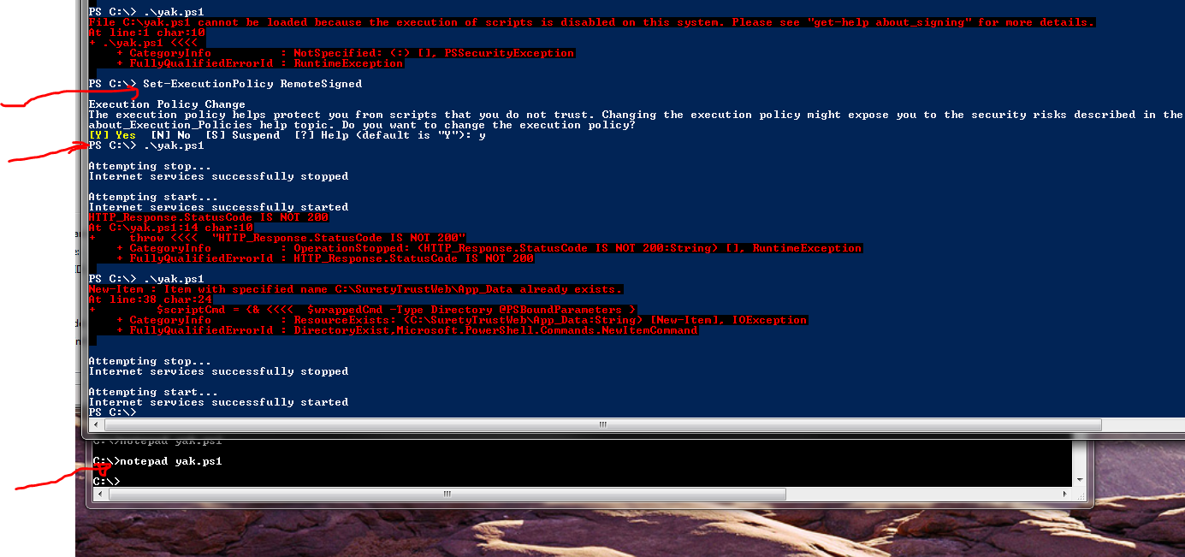

**-- TROUBLE-SHOOTING –**

* **Builds no longer creating Octopack nuget pachages**
  + Uninstall Octopack from package manager, push to Git, re-install OctoPack to the web project, push to Git
* **Getting Release already exists error from OctopusDeploy runner**

1. Download cmd tool from [**https://octopusdeploy.com/downloads**](https://octopusdeploy.com/downloads)
2. Delete releases via the following:[**http://octopusdeploy.com/blog/deleting-releases-via-command-line**](http://octopusdeploy.com/blog/deleting-releases-via-command-line)

c:\...\OctopusTools.2.5.4.35>Octo.exe delete-releases --project=SuretyTrust --minversion=1.0.86 --maxversion=1.0.200 --apikey=API-NB47… --server=http://localhost/octopus

**-- BELOW IS FOR REFERENCE –**

# Deployment Automation with Octopus Deploy and TeamCity <http://www.youtube.com/watch?v=JWGLEEm9Qhg>

**Vid @ 29.20 Adds build trigger and some snapshot dependency stuff ( I think it’s for creating builds that trigger not off a Git, but off of other builds running – in the vid he uses OctopusDeploy: Deploy release where I got working with OctopusDeploy: Create release -> found out later that I’m always deploying one build behind with the all-in-one build approach because NuGet packages are not created until after a build completes )**

**Vid @ 34.00 talks about different transforms that will run configs etc.**

**Vid @ 35 talks about adding artifact dependency**

**Vid @ 47 talks about adding an approval step in Octopus Deploy and approval permissions**

**Vid @ 51.21 talks about how to include release notes from teamcity**

**Vid @ ~55.00 talks about emails notifications with Octopus**

**Vid @ ~58.00 talks about using nuget to package anything and having Octopus Deploy it**

**Vid @ ~59.00 having teamcity schedule a build of some trigger**

**Vid @ ~21.00 shows how to deploy to other tentacles with different roles**

**Also shows how to set up variables like his SiteEnvironment variable he created in web config to show which staging environment was deployed**

**-- THINGS TO CONSIDER –**

**TC - Setting up an External Database**

<http://confluence.jetbrains.com/display/TCD8/Setting+up+an+External+Database#SettingupanExternalDatabase-DatabaseConfigurationProperties>

**TeamCity Data Backup**

<http://confluence.jetbrains.com/display/TCD8/TeamCity+Data+Backup>

**misc. links**

<http://docs.octopusdeploy.com/display/OD/Installing+Octopus>

<http://docs.octopusdeploy.com/display/OD10/TeamCity+Integration>

<http://docs.octopusdeploy.com/display/OD/TeamCity>

<http://docs.octopusdeploy.com/display/OD/Listening+Tentacles>

octo.exe <http://docs.octopusdeploy.com/display/OD/Deploying+releases>

<http://docs.octopusdeploy.com/display/OD/Packaging+applications>

<http://docs.octopusdeploy.com/display/OD/Configuration+files>

Making use of TeamCity’s NuGet capabilities

<http://johanleino.wordpress.com/2013/06/14/making-use-of-teamcitys-nuget-capabilities/>

<http://blog.jetbrains.com/teamcity/2011/12/setting-up-teamcity-as-a-native-nuget-server/>

teamcity nuget repository

<https://www.google.com/webhp?sourceid=chrome-instant&ion=1&espv=2&ie=UTF-8#q=teamcity%20nuget%20repository>

<http://docs.nuget.org/docs/start-here/managing-nuget-packages-using-the-dialog>

<http://www.developerfusion.com/article/144809/continuous-integration-using-nuget-and-teamcity/>

Build Artifacts

<http://confluence.jetbrains.com/display/TCD8/Build+Artifact>

PowerShell scripting

<http://stackoverflow.com/questions/2035193/how-to-run-a-powershell-script>

<http://www.iis.net/learn/publish/using-web-deploy/powershell-scripts-for-automating-web-deploy-setup>

<http://technet.microsoft.com/en-us/library/ee909471(v=ws.10).aspx>

<http://technet.microsoft.com/en-us/library/hh849901.aspx>

<http://stackoverflow.com/questions/20259251/powershell-script-to-check-the-status-of-a-url>

google keywords: powershell write-host exception

<http://social.technet.microsoft.com/Forums/scriptcenter/en-US/f9551e49-fe32-47f6-b4d0-f3e7e5858925/powershell-exceptions-trycatchthrow-how-to-use-them-with-conditionals?forum=ITCG>

# Build Step example using Visual Studio runner type

# 

